Nongciki, Ntlahla, (Mr) (s226083470);Senamile, Mhlaba ,(Miss)(229922171)
(excel)
Diba Bookings
Compiled documentation

Table of Contents
Introduction 2
1.1 Fragmented Conference Centre Venue Booking and Information 2
1.4.1 Booking.com 4
1.4.2 LibCal Spaces 6
1.4.3 Nelson Mandela University Virtual Tour 7
1.5 The Project Plan 9
Gantt Chart 10
1.6 Risk Analysis 10
Introduction 12
1.2.1 Information Scope 14
1.2.3 Communication Scope 23
1.3 Business requirements 27
1.4 Hardware and Software Requirements 30
1.4.1 Software Requirements 30
1.4.2 Hardware Requirements 30
1.5 Design constraints 32
1.5.1 Security Constraints 32
1.5.2 Interface Constraints 33
1.5.3 Performance Constraints 33
1.5.4 Development and Project Constraints 34
1.6 High-level use case diagram 34
1.6.1 Event Organiser Use Case Diagram 34
1.6.2 Conference Centre Staff Use Case Diagram 35
1.6.3 System Administrator Use Case Diagram 36
1.7 UML Class Model / Diagram 37
1.8 Relational Database Model Diagram 38
1.9 User Interface Design 40
Login screen 40
Registration screen 40
Event organiser 41
Search and view venue screen 41
Submission of booking requests 42
Viewing of booking history 42
Staff 43
Managing booking requests 43
Responding to enquiries 44
Adding and updating of venues 44
System admin 45
User account management 45
Management system settings 45
Update Profile 46
Implementation Document 47
Introduction 47
1.1 Choice of Tools 47
1.1.1 Microsoft Visual Studio 2022 47
1.1.2 ASP.NET Core Web API 47
1.1.3 C# 47
1.1.4 Entity Framework Core 48
1.1.5 Microsoft SQL Server Express 48
1.1.6 SQL Server Management Studio 48
1.1.7 React 48
1.1.8 Google AI Studio and Lovable 48
1.1.9 Swagger 48
1.1.10 Git 48
1.1.11 GitHub 48
1.1.12 Microsoft Edge 48
1.1.13 Microsoft Word 49
1.1.14 WhatsApp 49
1.1.15 ChatGPT 49
1.1.16 DeepSeek 49
1.1.19 Microsoft Learn and Online Technical Documentation 49
1.1.20 Previous Academic Material and GitHub Projects 49
1.1.21 Microsoft Excel 49
1.2 Extracts of Complex Code 49
1.2.1 Booking Conflict Validation 49
1.2.2 Booking Approval and Rejection 51
1.2.3 Notification Retrieval and User-Specific Access 52
1.2.4 Audit Logging 53
1.3 Source Code References 54
1.3.1 Role-Based Authorisation and JWT Authentication 54
1.3.2 Booking Conflict Validation 54
1.3.3 Conference Booking and Approval Processes 54
1.3.4 User Notifications 55
1.3.5 Audit Logging 55
1.3.6 Summary of Adapted External Sources 55
1.4 Problems Encountered 56
1.4.1 Developing the Project Idea and Requirements 56
1.4.2 Designing the System Before Development 56
1.4.3 Creating the Database Structure 56
1.4.4 Complexity of the Bookings Controller 57
1.4.5 Authentication and Authorisation 57
1.4.6 Booking Availability and Conflicting Bookings 58
1.4.7 Managing Booking Statuses 58
1.4.8 Frontend and Backend Communication 58
1.4.9 Testing Role-Specific Functionality 58
1.4.10 Coordinating Work Between Team Member 59
1.4.11 Limited Development Time and Laboratory Access 59
1.4.12 Slow Development Computers 59
1.4.13 Managing the Project Timeline 59
1.5 Implementation Summary 60
References 60
References 61

Campus Event & Venue Management System Business Case

Introduction
The purpose of this business case is to outline the proposed development of the Campus Event and Venue Management System, initially focusing on the Nelson Mandela University Conference Centre. The document establishes the context and justification for the project and provides a basis for planning its development.
The business case covers the problem domain, project objectives, and background research relevant to event and venue management. It also examines related software systems to identify features and approaches that may inform the proposed solution. In addition, the document presents the project plan, including the planned deliverables, milestones, responsibilities and development timeframe, followed by a risk analysis identifying factors that may affect the successful completion of the project.
The initial scope is limited to the Conference Centre to ensure that the project remains focused and achievable within the available development period.

1.1 Fragmented Conference Centre Venue Booking and Information
Organising an event at Nelson Mandela University (NMU) requires organisers to identify a venue that meets their needs in terms of availability, capacity, location and facilities. The initial focus of this project is the Conference Centre, where both internal university users and external organisations may require venues for events.
Preliminary investigation indicates that different booking approaches are used depending on the type of organiser. Internal users can submit requests through a staff portal and booking form, while external organisations primarily make enquiries through telephone calls and email. As a result, external organisers do not have a straightforward way to view venue availability and may enquire about venues that are already booked.
Determining availability can also require additional communication. Staff handling an enquiry may need to contact another office or person to confirm whether a venue is available. External organisers may therefore have to wait for information before they can proceed with their event planning. Telephone communication can create further difficulties when lines are unavailable, requiring organisers to use email instead.
Another challenge is the accessibility of venue information. External organisers may know about a particular venue through previous events or recommendations but may have limited knowledge of alternative venues. Information such as capacity, location, parking and available facilities is important when selecting an appropriate venue. Without easily accessible information about available alternatives, organisers may repeatedly enquire about venues they already know.
The current approach can also create repetitive administrative work. Staff may receive multiple telephone calls and emails requesting information about the same venue, while organisers may need to make additional enquiries when information was not provided during the initial communication. Important booking and venue information is therefore distributed across different communication channels and, in some cases, requires communication between university offices.
These challenges affect both event organisers and Conference Centre staff. Organisers may spend additional time identifying suitable venues and obtaining availability and venue information, while staff spend time responding to enquiries and confirming information. The problem addressed by this project is therefore the difficulty of efficiently accessing, communicating and managing venue information and booking requests during the Conference Centre's event planning process.
1.2 Project Objectives
The project aims to improve the efficiency and accessibility of the Conference Centre's venue booking and information processes. The system will:
- Centralise venue information by providing organisers with details such as venue capacity, location, facilities, parking and available equipment.
- Improve visibility of venue availability by providing users and authorised staff with up-to-date information about venue bookings and available time slots.
- Streamline booking requests by providing a structured digital process for submitting and monitoring venue booking requests.
- Assist organisers in finding suitable venues by allowing them to search and filter venues according to requirements such as capacity, facilities and availability.
- Provide centralised administrative management for authorised staff to maintain venue information and manage booking requests.
- Improve booking communication by providing organisers with booking status updates and relevant notifications.
- Reduce unnecessary administrative enquiries by making commonly requested venue and booking information accessible through the system.
1.3 Problem Background
Universities manage shared venues for a wide range of activities, including lectures, conferences, workshops, seminars, research presentations and student events. Venue management requires consideration of factors such as date, time, capacity, location, facilities and event requirements. Since multiple users may require the same spaces, accurate availability information and an organised booking process are important for effective use of university facilities.
Research has identified challenges associated with traditional and fragmented venue-booking processes. Heera et al. (2025) examined a campus venue-booking process and identified difficulties related to obtaining up-to-date venue information, communication and conflicting bookings. Their proposed system incorporated venue information, real-time availability and online booking functionality, demonstrating how centralised information can support more efficient venue management.
Similar approaches have been explored in other university environments. Khamaruzaman et al. (2025) investigated a digital space-booking solution for architecture schools at Universiti Teknologi MARA. The proposed system included features such as a visual booking calendar, real-time room availability and automated booking confirmations. These features were intended to improve space planning, reduce booking conflicts and assist users in selecting suitable spaces.
Nelson Mandela University (NMU) already provides some digital venue information. Its online venue timetable provides information about scheduled activities and venue details, including capacity (Nelson Mandela University, 2026). The university has also published information about venues available for external use, including venue capacities and rates (Nelson Mandela University, n.d.). These resources show that venue information is already available digitally, but information provision and booking management are separate aspects of the overall process.
Existing commercial scheduling systems demonstrate how these activities can be integrated. For example, 25Live provides tools for event and space scheduling, including availability checking, booking requests, approval workflows, resource management, calendar publishing and reporting (CollegeNET, n.d.). Such systems demonstrate that venue management can extend beyond displaying schedules to supporting the different stages of a booking process.
Overall, the literature indicates that effective venue-management systems can benefit from centralised venue information, availability visibility, structured booking processes and administrative controls. These findings provide a basis for investigating how similar principles could be applied to the NMU Conference Centre while taking into account its specific requirements and existing processes.
1.4 Related Systems Analysis
Existing venue and space-management systems were reviewed to identify approaches that could inform the development of DIBA Bookings. The systems selected demonstrate different approaches to venue discovery, availability management, booking and physical-space navigation.

1.4.1 Booking.com
Platform: Web-based
Description:
Booking.com is a web-based accommodation booking platform that allows users to search for accommodation based on criteria such as location, dates, number of guests and property type. Users can compare available options, view detailed information about properties, check prices and availability, and make reservations through the platform. The system provides a centralised interface that allows users to discover and compare options before making a booking decision.
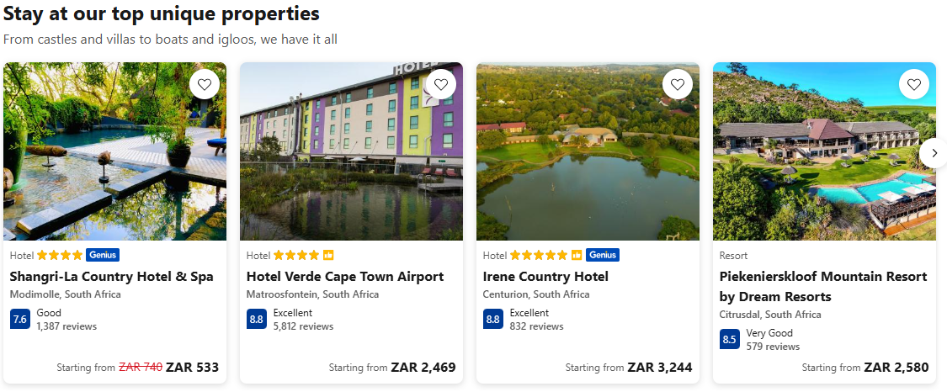
Figure 1: demonstrates how Booking.com presents different accommodation options, including images and key details, allowing users to compare available choices.
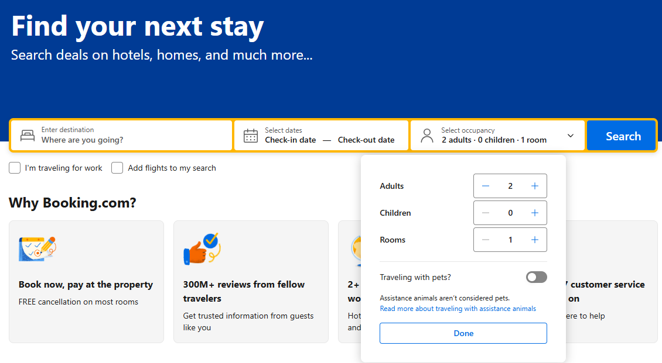
Figure 2: demonstrates the search and filtering functionality, which allows users to narrow available options according to their requirements.
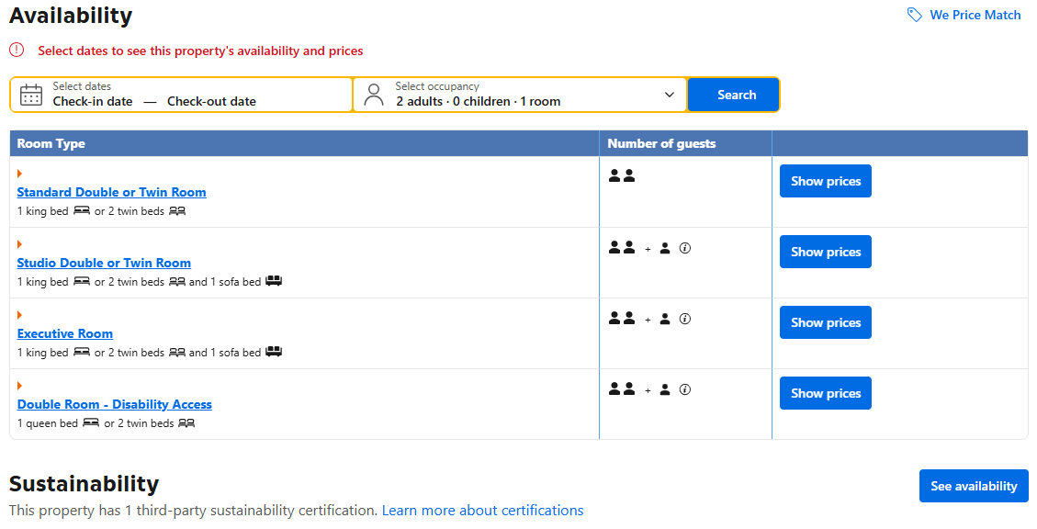
Figure 3: demonstrates how availability can be determined based on the user's selected dates.
Features/processes to adapt:
- Search and filtering of venues based on requirements such as capacity, date and facilities.
- Clear display of venue availability.
- Structured booking-request workflow.
- Role-based access for different types of users.
- Clear presentation of space information.
Features/processes to avoid:
- Excessively complex configuration that is unnecessary for a small initial implementation.
- Advanced enterprise scheduling functionality outside the project's scope.

1.4.2 LibCal Spaces
Platform: Web-based
Description:
LibCal Spaces is a space-reservation component of the LibCal platform developed by Springshare. It allows organisations to make physical spaces available for online discovery and reservation. Users can view available spaces, search according to requirements and submit reservations through the platform.
Figure 1.2: LibCal Spaces reservation interface.
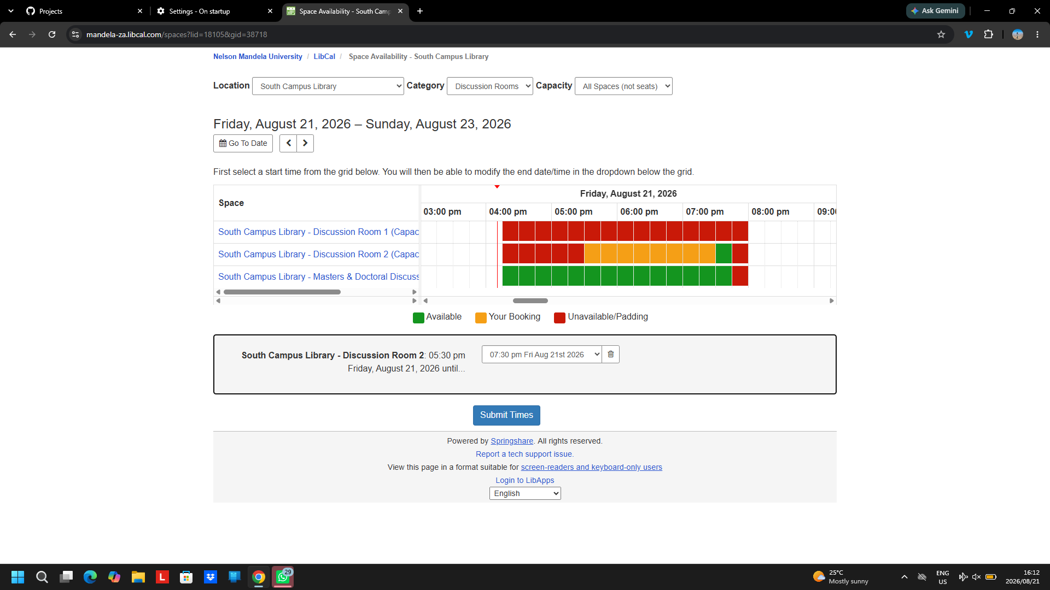
Figure 4: LibCal Spaces availability calendar displaying available and occupied time slots
Features/processes to adapt:
- Visual availability calendars.
- Online reservation requests.
Features/processes to avoid:
- Features primarily intended for library study spaces, such as individual-seat reservations.

1.4.3 Nelson Mandela University Virtual Tour
Platform: Web-based
Description:
Nelson Mandela University's virtual tour provides an interactive way for users to explore university campuses remotely. The tour provides a visual representation of campus locations and facilities and can help users become familiar with physical spaces before visiting them.
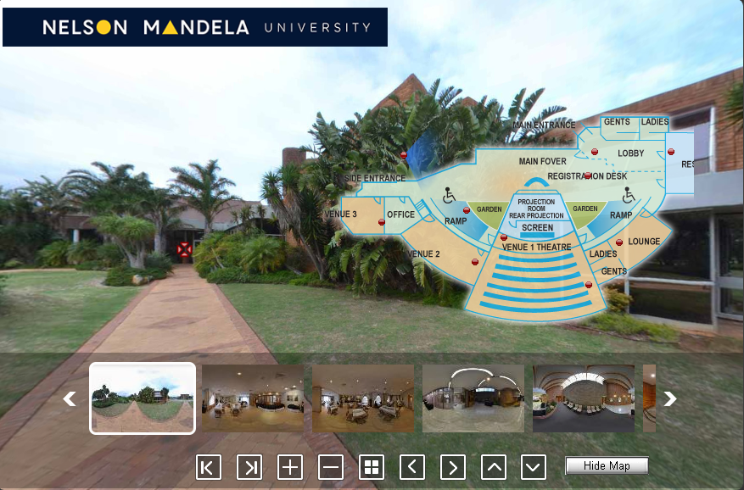
Figure 5: demonstrates the NMU Virtual Tour map, which provides users with a visual representation of campus locations and assists them in identifying where facilities are situated.
Features/processes to adapt:
- Interactive visual representation of venues.
- Location information to help users understand where a venue is situated.
Features/processes to avoid:
- Treating the virtual tour as a standalone discovery tool without connecting it to the booking process.
- Including extensive campus-tour functionality that is unrelated to venue booking.

1.5 The Project Plan
Table 1: Project overview
Item | Details
Project name | DIBA Bookings – Campus Venue and Event Management System
Proposed client/domain | Nelson Mandela University Conference Centre
Project team | Ntlahla and Sena
Project manager | Ntlahla
Project duration | 11 weeks
Development approach | Iterative development

Table 2: Stakeholders and their responsibility
Stakeholder | Responsibility
Conference Centre staff | manage venues and booking requests
Internal university users | staff, departments and student organisations requiring venues.
External event organisers | users who may request Conference Centre facilities.
Project team | responsible for analysing, designing and developing the system.
Project lecturer/supervisor | provides academic guidance and feedback.

Activity / Deliverable | Dependency
Requirements analysis | Preliminary investigation and problem definition
System design | Completed requirements analysis
Database design | Requirements analysis and system design
User interface design | Requirements analysis and system design
User authentication & role-based access | Database design and system design
Venue information management | Database design
Venue availability management | Venue database and booking structure
Venue search & filtering | Venue information and database structure
Event management | Database design and requirements
Booking request & approval | User, venue and event functionality
Notifications & booking status | Booking workflow
Administrative management | User roles, venue and booking functionality
Reporting | Completed booking and event data
System integration | Core modules completed
Testing | Integrated and functional system
User documentation | Stable system and user workflows
Source code/version control | Begins with development and continues throughout project
Final deployment/presentation | Testing and final corrections completed
Table 3: Project deliverables and Dependencies

Gantt Chart

Diba Bookings Project start: _{Fri, 7/31/2026}
DB Devs, Ltd. Project lead Display week: 1
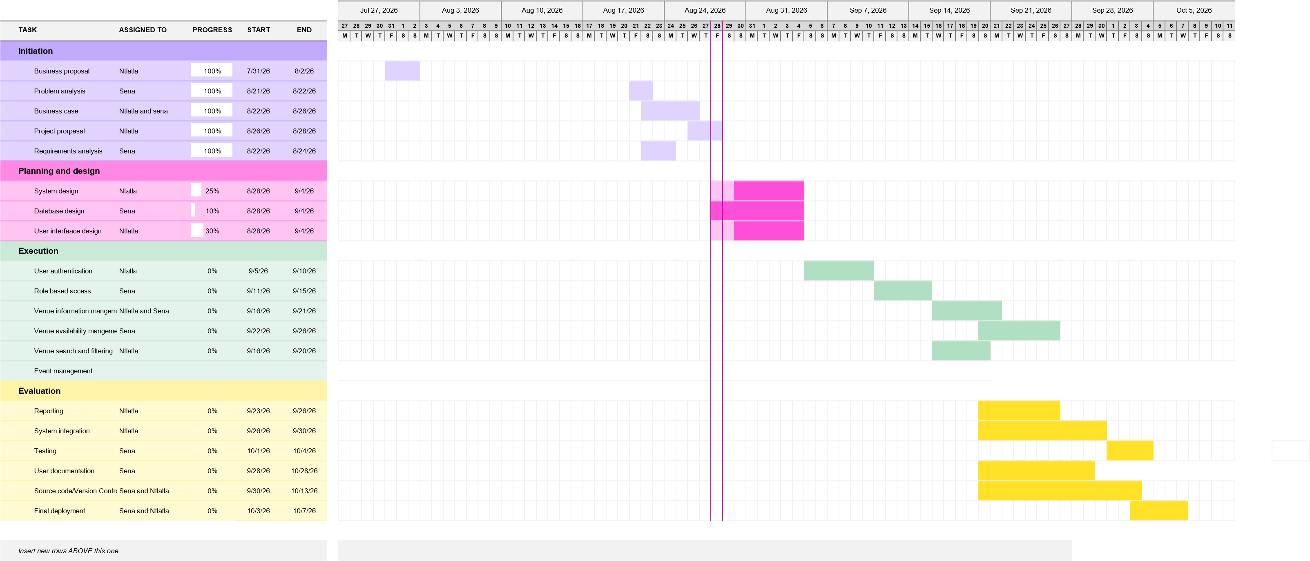

1.6 Risk Analysis
The project may be affected by several risks relating to stakeholder availability, project scope, development time and security. These risks have been considered so that appropriate actions can be taken to reduce their likelihood or impact.
Table 4: Project risk analysis
Risk | Type | Likelihood | Impact | Treatment
Limited stakeholder availability and feedback | Minimizable | High | High | Continue development using preliminary investigation, existing university information, literature and related-system research. Attempt to obtain stakeholder feedback where possible and incorporate it into later iterations.
Project scope becoming too large | Avoidable | High | High | Initially limit the system to the Conference Centre. Prioritise essential booking functionality and only add other venues or optional features if sufficient time remains.
Insufficient development time | Minimizable | High | High | Use weekly milestones, prioritise core functionality and begin development early. Optional features will be reduced or postponed if the project falls behind schedule.
Security vulnerabilities | Minimizable | Medium | High | Implement authentication, role-based access, input validation and appropriate database security. Security will be considered throughout development and included in system testing.

System Requirements
Specifications and Technical Design

Introduction

This document presents the System Requirements Specification (SRS) and Technical Design for the proposed DIBA Bookings Campus Venue and Event Management System. The purpose of the document is to define the requirements, functionality, technical structure, and design of the proposed system based on the problem domain and objectives identified in the business case.

The document describes the functional and non-functional requirements of the system, including the requirements for users, venues, events, bookings, availability, administration, and notifications. It also defines the system's technical design, including its architecture, database structure, user interfaces, system processes, and security considerations.

The document will provide the foundation for the development of the system by translating the identified business needs into clear, implementable system requirements and technical specifications. Where requirements have not yet been confirmed by Conference Centre stakeholders, they will be treated as preliminary requirements and refined as additional stakeholder information becomes available.

  - Plan to Address Objectives

The proposed system will address the identified objectives through a centralized web-based venue and event management platform. The following table outlines the main software interventions and how each will contribute to addressing the identified real-world problems.

Objective | Planned Software Intervention | How It Addresses the Objective
1. Centralise venue information | Develop a centralised web-based venue catalogue containing venue details such as capacity, location, facilities, parking and available equipment. | Organisers can access commonly requested venue information from one location without relying on repeated phone calls or emails.
2. Improve venue availability visibility | Provide venue availability information through venue status and booking conflict validation. The system checks existing Pending and Approved bookings when a booking request is created or updated to help prevent overlapping reservations for the same venue | Organisers can check venue availability before submitting a request, while authorised staff can view existing bookings in one place.
3. Streamline booking requests | Implement a digital booking form and booking workflow through which organisers can submit and monitor requests. | Replaces fragmented booking enquiries with a structured process and gives organisers visibility of their booking status.
4. Assist organisers in finding suitable venues | Implement venue search and filtering based on criteria such as capacity, facilities, location and availability. | Organisers can identify suitable alternatives instead of relying on staff to recommend available venues manually.
5. Provide centralised administration | Provide an administrative interface for authorised staff to manage venues, availability, bookings and booking requests. | Staff can manage relevant information from a central system rather than relying on separate records and communication channels.
6. Improve booking communication | Implement booking-status updates and system notifications for events such as request submission, approval, rejection or changes. | Organisers remain informed about their requests without repeatedly contacting staff for updates.
7. Reduce unnecessary enquiries | Provide self-service access to venue information, availability and booking-status information. | Users can obtain common information independently, reducing repetitive enquiries handled by administrative staff.

1.2 Project Scope

The proposed DIBA Bookings – Campus Venue and Event Management System will be a web-based system designed to support the discovery, booking, administration, and management of university event venues. The initial implementation will focus on the Nelson Mandela University Conference Centre, providing a manageable environment in which the proposed processes and functionality can be developed and evaluated.

The system will provide functionality for different categories of users, including event organisers, internal university users, and authorised Conference Centre administrators. Users will be able to access relevant venue information, search for suitable venues, view availability, submit booking requests, and monitor the progress of their requests. Administrators will have additional functionality for managing venue information, bookings, availability, and user-related activities.

The scope is divided into information, functional, and communication scope to define what information the system will manage, what activities the system will support, and how users and the system will communicate.

1.2.1 Information Scope

The information scope defines the data that the proposed system will capture, store, retrieve, update, and manage.

Venue Information

The system will maintain information about venues available through the Conference Centre. The venue information will include:
- Venue identification.
- Venue name.
- Venue description.
- Venue location.
- Maximum capacity.
- Venue status.
- Venue-specific features.

This information will allow users to evaluate venues before submitting a booking request.

User Information

The system will maintain information required to identify and manage system users. Depending on the user's role, this may include:
- User identification.
- First name.
- Last name.
- Email address.
- Phone number.
- Password hash.
- User role.
- Account status.
- Account creation information.
Different roles will have different permissions. For example, an organiser should not have the same management privileges as an administrator.

Event Information

The system will store information about events associated with venue bookings. This may include:

- Event identification.
- Event name.
- Event description.
- Event type.
- Expected event attendance.
- Start date and time.
- End date and time.
- Associated venue.
- Event organiser.
The event information will be associated with the relevant booking and organiser.

Booking Information

Booking records will contain information required to manage requests and reservations. This may include:

- Booking identification.
- Event.
- Event organiser.
- Requested venue.
- Booking date.
- Start date and time.
- End date and time.
- Special requirements.
- Booking status.
- Administrative notes.
Possible booking statuses may include Pending, Approved, Rejected, Cancelled, and Completed.

Payment Information

The system will maintain payment records associated with bookings for payment tracking purposes. Payment information will include:
- Payment identification.
- Payment amount.
- Payment date.
- Payment reference number.
- Associated booking.
The initial implementation records payment information but does not process online financial transactions or integrate with an external payment gateway.

Audit Information
The system will maintain audit records for important system activities to support accountability. Audit records will include:
- Audit log identification.
- Action performed.
- Description of the action.
- Timestamp.
- User responsible for the action.
Audit records provide an administrative history of important activities performed within the system.

Availability Information

The system will maintain information required to determine whether a venue can be requested for a particular period.

Availability will be linked to existing bookings and relevant venue restrictions. The system should prevent conflicting bookings from being created for the same venue and overlapping time period.

Notification and Communication Information

The system may store records associated with notifications and booking updates, including:

- Notification type.
- Recipient.
- Related booking.
- Date and time.
- Notification status.
- Relevant message or update.

This will allow users to remain informed about important changes to their booking requests.

Administrative Information

Authorised administrators will be able to manage information required to operate the system. This may include:

- Venue records.
- Venue availability.
- Booking requests.
- User accounts and roles.
- Event information.
- Booking statuses.
- Administrative notes.
- System-generated records required for reporting and auditing.
- Data Storage and Security

The system will use a relational database as the primary storage mechanism for structured system information. Data will be accessed through the web application rather than being maintained through separate spreadsheets, emails, or manually managed records.

Sensitive information, particularly authentication credentials, must be protected using appropriate security practices. Passwords should not be stored as plain text, and access to information should be controlled according to the user's role.

The system should also maintain sufficient records to support accountability, such as when a booking was submitted or when its status was changed.

1.2.2 Functional Scope

The functional scope describes the activities that users will be able to perform through the system.

User Registration and Authentication

The system will provide authentication functionality allowing users to securely access the platform.

Users will be assigned appropriate roles, such as:

- External organiser
- Internal university user
- Administrator

The system will use role-based access control to ensure that users can only access functionality appropriate to their responsibilities.

Venue Discovery

Users will be able to browse venues through a centralised venue catalogue. Venue profiles will provide information including venue name, description, capacity, location, venue status and associated venue features.

Venue Search and Filtering

The system will provide search and filtering functionality to help organisers identify appropriate venues.

Users may be able to filter venues according to criteria such as:

- Required capacity
- Event date
- Availability
- Location
- Accessibility requirements

This will also allow the system to suggest or display alternative venues when a preferred venue is unavailable.

Availability Management

Users will be able to view venue availability through a calendar or similar scheduling interface. The system will use existing booking information to determine whether a venue is available for a requested date and time. Administrators will be able to update availability where necessary, particularly where a venue is unavailable for reasons that are not represented by a normal booking.

Event Creation and Management

Organisers will be able to create an event associated with a venue booking. The event-management functionality will allow organisers to provide information such as the event name, date, time, expected attendance, event type, and venue requirements. Organisers should also be able to view and update relevant event information where changes are permitted.

Booking Request

The system will provide a structured booking process.

An organiser will be able to:

- Search for a suitable venue.
- View its information.
- Check its availability.
- Select a date and time.
- Provide event information.
- Submit a booking request.
- Receive confirmation that the request has been submitted.
- Monitor the status of the request.

The system will record the request and make it available to authorised administrators.

Booking Approval and Management

Administrators will have functionality for reviewing booking requests.

An administrator should be able to:

- View pending requests.
- Review event and organiser information.
- Check venue availability.
- Approve requests.
- Reject requests.
- Cancel bookings where appropriate.
- Add relevant comments.
- Update booking status.

The system should help prevent conflicting reservations by checking existing bookings before a request is approved.

Booking Status Tracking

Organisers will be able to monitor the progress of their requests without repeatedly contacting the Conference Centre.

The system will display the current status of each booking, such as:

Pending → Approved / Rejected → Completed or Cancelled

Where appropriate, the system will also provide information explaining changes to a request.

Administrative Dashboard

Administrators will have access to a central dashboard providing an overview of relevant activities.

The dashboard may include:

- Pending booking requests.
- Upcoming events.
- Current bookings.
- Venue availability.
- Recently submitted requests.
- Booking statistics.
- Alerts or notifications requiring attention.

The dashboard will provide administrators with a consolidated view of the booking process.

Venue Management

Administrators will be able to create, update, and manage venue records.

This includes maintaining information such as capacity, facilities, equipment, images, and availability.

This functionality is important because venue information may change over time and should be maintained from a central location.

Notifications

The system will provide notifications for important booking events.

Examples include:

- Booking request submitted.
- Booking approved.
- Booking rejected.
- Booking cancelled.
- Booking details changed.
- Other important administrative updates.

Notifications may initially be provided through the web application, with email notifications considered where technically feasible.

Reporting

The system will provide basic reporting functionality to assist administrators in understanding venue and booking activity.

Possible reports include:

- Upcoming bookings.
- Bookings by venue.
- Bookings by date.
- Booking status summaries.
- Venue utilisation.
- Event activity over a selected period.

Reporting functionality will remain focused on information useful for managing the Conference Centre rather than attempting to provide extensive business intelligence functionality.

Help and Guidance

The system will provide basic guidance to users on how to navigate the booking process.

This may include:

- Booking instructions.
- Explanation of booking statuses.
- Frequently asked questions.
- Information about required booking details.
- Contact information for relevant administrative support.
- Location-Related Functionality

Where appropriate, the system may provide location-related information to help organisers identify where venues are situated.

This could include:

- Venue location information.
- Campus location.
- Parking information.
- Map-based representation.

The exact implementation of location functionality will depend on the final technical requirements and available resources.

Security and Access Control

The application will include appropriate security controls, including:

- User authentication.
- Role-based authorisation.
- Protected administrative functions.
- Secure handling of passwords.
- Input validation.
- Session management.
- Protection against unauthorised access.

Security will be considered throughout development rather than being added only after the system has been completed.

Testing and Error Handling

The system will include validation and error-handling mechanisms to prevent invalid information from being submitted.

For example, the system should identify:

- Missing required information.
- Invalid dates or times.
- Invalid user information.
- Booking conflicts.
- Unauthorised access attempts.

The completed system will also be tested against defined test cases to determine whether its main functions operate as intended.

1.2.3 Communication Scope

The communication scope describes how users will interact with the system and how information will be communicated between the application, users, and administrators.

Web-Based Access

DIBA Bookings will be developed as a web-based application. Users will access the system through a modern web browser rather than requiring a dedicated desktop application.

This approach allows the system to be accessed from computers and other suitable internet-connected devices without requiring users to install specialised software.

User-to-System Communication

Users will communicate with the system through web interfaces.

Examples include:

- Login forms.
- Venue search interfaces.
- Venue information pages.
- Availability calendars.
- Booking forms.
- Event-management interfaces.
- Booking-status pages.
- Administrative dashboards.

Information entered by users will be transmitted to the application and stored in the system database where appropriate.

System-to-User Communication

The system will communicate important information to users through:

- On-screen confirmations.
- Booking status indicators.
- Notifications.
- Validation messages.
- Error messages.
- Administrative updates.

For example, after submitting a booking request, the organiser should receive confirmation that the request has been successfully recorded.

Booking Notifications

The system should notify organisers when important changes occur to their booking.

For example:

Booking request submitted → Pending

and later:

Booking request approved → Approved

The initial implementation will prioritise in-system notifications. Email notifications may be incorporated if they are practical within the available development environment.

Administrator Communication

Administrators will interact with the system through their administrative interface.

When a booking request is submitted, the relevant information will become available to authorised administrators. Administrators will then be able to review the request and update its status.

This reduces the need for the booking process to depend entirely on separate telephone calls or email conversations.

Internet Connectivity

Because the system is web-based, users will require network connectivity to access the application and retrieve current information.

The system is not initially intended to provide an offline booking mode. This is appropriate because venue availability needs to be based on centrally managed information. Allowing bookings to be created offline could introduce conflicts when multiple users attempt to reserve the same venue.

Communication with External Services

The initial system will primarily communicate between the web application and its database.

Where required, external services may be incorporated for specific functionality, such as:

- Email notification services.
- Mapping/location services.
- Authentication services.

Any external service integration will be considered according to project requirements, technical feasibility, security, and available development time.

Scope Boundaries

To prevent the project from becoming unnecessarily large, the following boundaries should also be established.

Included

The initial system will include:

- Conference Centre venue management.
- Venue information.
- Venue search and filtering.
- Availability viewing.
- Event creation.
- Booking requests.
- Booking approval.
- Booking-status tracking.
- User authentication.
- Role-based access.
- Administrative management.
- Basic notifications.
- Basic reporting.
- Venue/location information.
- Security and validation.
- Payment record tracking.
- Audit logging.

Outside the Initial Scope

The following will not form part of the core implementation unless additional requirements or development time make them feasible:

- Online financial transaction processing
- Integration with external payment gateways
- Online invoicing
- Catering management
- Full security-service management
- Complex procurement processes
- Advanced AI-based venue recommendations
- Dedicated Android/iOS applications
- Offline booking
- Integration with every existing NMU system
- Enterprise-level reporting and analytics

Scope Summary

In summary, the project will focus on creating a centralised web-based platform for discovering, requesting, approving, and managing Conference Centre venues and events. The information scope defines the data required to support these activities, the functional scope defines the services provided by the application, and the communication scope defines how users, administrators, and supporting services interact with the system.

1.3 Business requirements

The business requirements describe the needs and expectations of the main users of the proposed DIBA Bookings system. The requirements are based on the problem identified in the business case, research into related venue-management systems, and the intended functionality of the proposed solution. Detailed functional and non-functional requirements will be specified later in the project.

1.3.1 Event Organisers

Event organisers require a system that makes it easy to identify and request a suitable venue without relying primarily on telephone calls or email communication.
The system should:
- Provide accessible and up-to-date venue information, including capacity, location, facilities, parking and available equipment.
- Allow organisers to search and filter venues according to their event requirements.
- Allow organisers to view venue availability before submitting a booking request.
- Provide information about alternative venues when a preferred venue is unavailable.
- Provide a simple and structured booking process for submitting event and venue requirements.
- Allow organisers to view their submitted booking requests and their current status.
- Provide clear notifications when a booking is submitted, approved, rejected, cancelled, or otherwise updated.
- Reduce the need to contact Conference Centre staff for information that can be obtained directly through the system.
- Provide a clear and easy-to-use interface that does not require specialised technical knowledge.

1.3.2 Internal University Users

Internal users, including university departments, staff members and student organisations, require a consistent method of finding and requesting venues for university-related activities.
The system should:
- Allow users to access relevant venue information.
- Allow users to search for venues based on event requirements.
- Provide visibility of venue availability.
- Allow users to submit booking requests digitally.
- Allow users to monitor the progress of their requests.
- Provide relevant booking notifications and updates.
- Apply appropriate access permissions according to the user's role.
- Reduce unnecessary communication with Conference Centre staff.
- Provide a consistent booking experience rather than requiring users to rely on different processes or communication channels.

1.3.3 Conference Centre Staff

Conference Centre administrators require a centralised system for managing venue information and booking requests.
The system should:
- Allow staff to access venue information.
- Allow staff to manage venue records and venue features.
- Allow staff to view booking requests.
- Allow staff to review booking information.
- Allow staff to approve or reject booking requests.
- Allow staff to cancel bookings where appropriate.
- Allow staff to view payment records.
- Allow staff to access relevant audit information.
- Apply role-based permissions to staff functions.

1.3.4 System Administrators

System Administrators are responsible for broader system administration and authorised administrative functions.
The system should:
- Provide access to booking management.
- Allow administrators to manage venue information.
- Allow administrators to manage venue features.
- Allow administrators to review booking requests.
- Allow administrators to approve, reject and cancel bookings where appropriate.
- Allow administrators to provide rejection reasons and administrative notes.
- Allow administrators to view payment records.
- Provide access to audit logs.
- Support role-based access control.
- Provide information required to monitor system activity.

1.3.5 Common Business Requirements

In addition to the needs of individual user groups, the system should satisfy several requirements that apply across the booking process.
The system should:
- Provide a central source of venue and booking information.
- Ensure that users receive consistent information about venues and their availability.
- Prevent or minimise double-booking of venues.
- Protect information through appropriate authentication and role-based access.
- Provide reliable access through a web browser.
- Validate information entered during the booking process.
- Maintain accurate booking statuses.
- Provide sufficient information to support communication between organisers and administrators.
- Be sufficiently simple to allow users to complete common tasks without extensive training.

Business Requirements Summary
User group | Primary business needs
Event organisers | Find suitable venues, view availability, submit bookings, monitor requests and receive updates.
Internal university users
Conference Centre administrators | Manage venues, review and process bookings, maintain availability, prevent conflicts and monitor activity.
All users | Access accurate information through a centralised, secure and easy-to-use web-based system.

1.4 Hardware and Software Requirements

The DIBA Bookings system will be developed as a web-based application. The following hardware and software will be required for development, testing, hosting, and use of the system.

1.4.1 Software Requirements

- Microsoft Visual Studio will be used as one of the primary development environments for the backend and .NET components of the system.
- ASP.NET Core will be used to develop the server-side application and API functionality.
- React will be used to develop the web-based user interface.
- Microsoft SQL Server will be used as the relational database for storing users, venues, events, bookings, availability and other system information.
- Entity Framework Core may be used to facilitate communication between the ASP.NET application and the database.
- Git and GitHub will be used for source-code version control, collaboration and backup of the project source code.
- Google Chrome will be the primary browser used during development and testing, although the completed system should be accessible through other modern web browsers.
- Figma may be used for designing and refining the user interface and creating prototypes before implementation.

User Software Requirements
Users will require:
- A modern web browser such as Google Chrome, Microsoft Edge, Mozilla Firefox, or Safari.
- An active internet or network connection to access the web-based system.
- No dedicated application installation will be required on the user's device.

1.4.2 Hardware Requirements

Development Hardware

The development team will require computers capable of running the development tools and local application environment. Each development computer should have at minimum:
- A modern multi-core processor.
- 8 GB RAM or more, with 16 GB recommended for comfortable development.
- Sufficient storage for the development environment, source code and database.
- A stable internet connection.
- A display capable of comfortably working with the development environment and browser simultaneously.

User Hardware
Because DIBA Bookings is web-based, users will not require specialised hardware.
The system may be accessed using:
- Desktop computers.
- Laptop computers.
- Tablets.
- Other suitable devices capable of running a modern web browser.

Users will require a stable network or internet connection when accessing the system.

Hosting Hardware

The completed application will require a server or suitable cloud-hosting environment capable of running:
- The ASP.NET application/API.
- The React web application.
- The Microsoft SQL Server database.

The exact server specifications will depend on the final deployment environment, expected number of users, database size and available hosting resources. These requirements can therefore be refined during the deployment phase.

Development vs User Requirements
Requirement | Development Team | System Users
Computer/device | Development computer | PC, laptop, tablet or suitable device
Operating system | Windows recommended for the selected development tools | Any OS supporting a modern browser
RAM | 8 GB minimum; 16 GB recommended | No specialised requirement
Browser | Chrome/Edge for testing | Modern web browser
Internet | Required for development, GitHub and external services | Required to access the system
Software installation | Visual Studio, .NET, React/Node.js, SQL Server and supporting tools | No application installation required
Database | Local SQL Server during development | Accessed through the web application
Version control | Git/GitHub | Not required

1.5 Design constraints

The development of DIBA Bookings will be subject to several constraints that may influence the design, implementation, and deployment of the system. The main constraints relate to security, the user interface, system performance, and the project's limited development time and resources.

1.5.1 Security Constraints

DIBA Bookings will store information relating to users, events and venue bookings. Although the system is not expected to manage highly sensitive medical or financial information, unauthorised access could still expose personal information or allow users to modify bookings incorrectly.

The following security constraints will therefore apply:
- Users must authenticate before accessing functions that require an account.
- Role-based access control must restrict administrative functions to authorised users.
- User passwords must not be stored as plain text and should be securely hashed.
- Communication between the browser and server should use HTTPS when the system is deployed.
- Users should only be able to access or modify information appropriate to their role.
- Administrative functions must not be accessible to ordinary organisers.
- The system must validate user input to reduce the risk of malicious or invalid data being submitted.
- Booking information must be protected against unauthorised modification.
- Database access should be restricted to the application and authorised development/administrative users.
- Authentication sessions should be managed securely.
- Development code and database credentials must not be exposed through the public source-code repository.
- The system should maintain appropriate records of important administrative actions where required.

Security must be considered throughout development rather than being treated as a feature added at the end of the project.

1.5.2 Interface Constraints

The system will be used by different types of users with potentially different levels of technical experience. The interface must therefore be simple, consistent and easy to understand.

The following interface constraints will apply:
- The system must provide a clear and intuitive user interface for finding venues and submitting bookings.
- Venue information should be presented in a manner that allows users to compare venues easily.
- The booking process should avoid unnecessary steps and confusing forms.
- Important information such as venue availability and booking status should be clearly visible.
- The system should provide clear feedback when an action is successful or unsuccessful.
- Forms should clearly identify required information and provide understandable validation messages.
- The interface should be responsive, allowing the system to be used on desktop computers, laptops, tablets and suitable mobile devices.
- The interface should maintain a consistent navigation structure across the system.
- Administrative interfaces may contain more functionality than organiser interfaces but should remain understandable and organised.
- Accessibility should be considered when selecting interface elements, text sizes, labels and colour combinations.
The design should also avoid unnecessarily reproducing the complexity found in large enterprise-level venue-management systems, as the initial implementation is focused on the Conference Centre.

1.5.3 Performance Constraints

The system should provide an acceptable response time when users search for venues, view availability and submit booking requests.

The following performance constraints will apply:
- Venue searches and filtering should return results efficiently.
- Availability information should be retrieved without unnecessary delays.
- Booking requests should be processed promptly after submission.
- The system should be able to handle multiple users accessing venue and booking information without significant degradation during normal use.
- The application should avoid loading unnecessarily large amounts of data when displaying venue information.
- Images and other media used by venue profiles should be appropriately optimised to reduce loading times.
- The system should prevent duplicate or conflicting booking requests through appropriate validation and database checks.

Because the project is being developed by a two-person student team, performance optimisation will focus on the core functions of the system rather than attempting to achieve enterprise-level scalability.

1.5.4 Development and Project Constraints

The project is also subject to practical development constraints.
- The project is being developed by two students, limiting the amount of development and testing that can be completed simultaneously.
- The project has a fixed academic timeframe, requiring features to be prioritised.
- Access to detailed Conference Centre requirements may be limited because stakeholder responses have not yet been received.
- Some requirements will therefore initially be based on preliminary investigation, research and analysis of related systems and will need to be validated when stakeholder feedback becomes available.
- The system should prioritise a Minimum Viable Product (MVP) containing the core booking and venue management functionality before optional features are implemented.
- The selected technologies must be compatible with the team's available development skills, hardware and software environment.
- Integration with existing Nelson Mandela University systems is outside the initial scope unless the required access and technical information become available.

1.6 High-level use case diagram

The proposed DIBA Bookings system will support different categories of users with different responsibilities and interactions. To improve readability, the use cases are divided into three diagrams representing the Event Organiser, Conference Centre Staff, and System Administrator.

1.6.1 Event Organiser Use Case Diagram

Actor: Event Organiser
The Event Organiser interacts primarily with the system to discover suitable venues, submit and manage booking requests, and receive information about the progress of bookings.

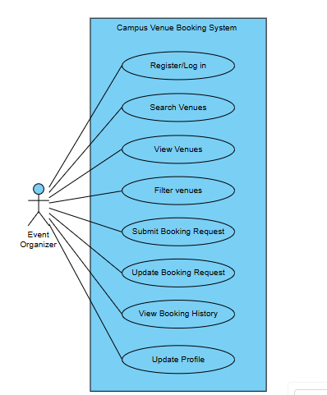
Figure 1: High-level use case diagram for the Event Organiser.

1.6.2 Conference Centre Staff Use Case Diagram

Actor: Conference Centre Staff
Conference Centre staff are responsible for managing venue information and processing booking requests. They require greater access to booking and venue-management functions than event organisers.
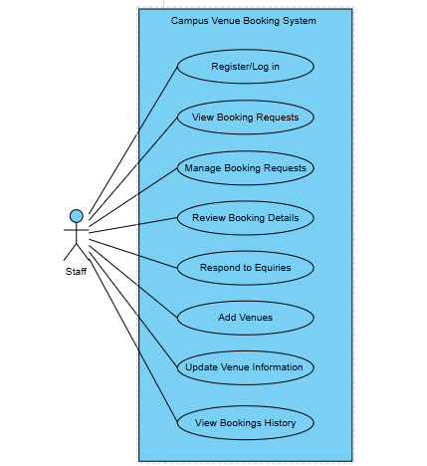
Figure 2: High-level use case diagram for Conference Centre Staff.

1.6.3 System Administrator Use Case Diagram

Actor: System Administrator
The System Administrator is responsible for managing the system itself, including users, roles, system information and administrative configuration.

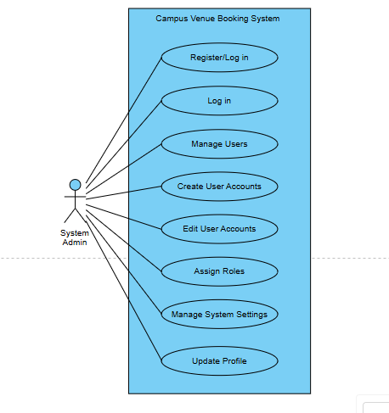
Figure 3: High-level use case diagram for the System Administrator.

1.7 UML Class Model / Diagram

The UML class diagram represents the main classes that form the DIBA Bookings system and their relationships. The model includes users, roles, venues, venue features, events, bookings, booking statuses, notifications, payments and audit logs. The associations represent how these entities interact within the application and correspond to the relationships implemented in the backend domain model.
The Role class is associated with User to support role-based access control. User is associated with events, bookings, notifications and audit logs. Venue is associated with events, bookings and venue features. Booking is associated with an event, venue, booking status, payments and notifications.
The system does not use class inheritance for user roles. Instead, Administrator, Staff and Event Organiser are represented as role values associated with the User entity.

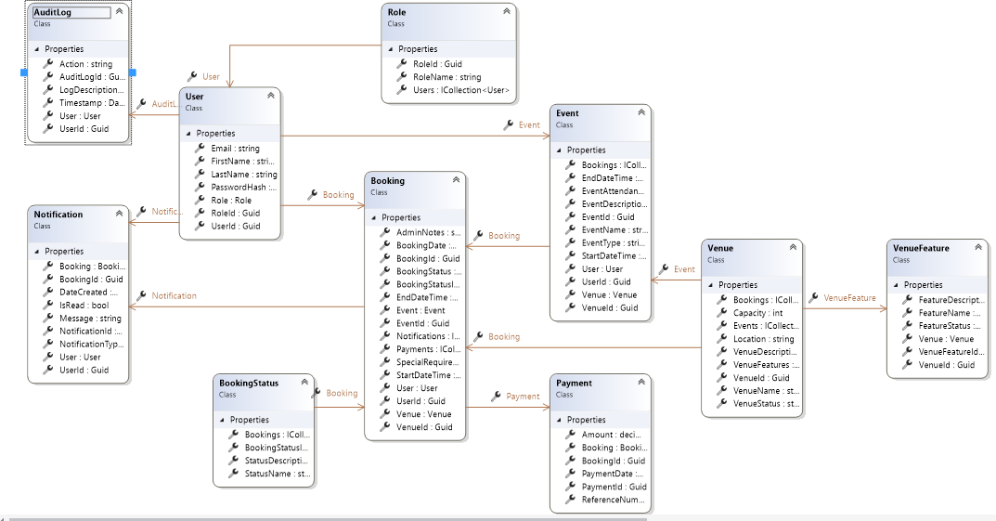
Figure 4: UML Class Model / Diagram

1.8 Relational Database Model Diagram

The relational database model represents the database structure used by the DIBA Bookings system. The database contains tables for users, roles, venues, venue features, events, bookings, booking statuses, notifications, payments and audit logs.
Primary keys uniquely identify records, while foreign keys establish relationships between related tables. The model supports the central booking workflow by linking users to their roles, events and bookings, while bookings are linked to venues, booking statuses, payments and notifications. Audit logs are linked to users to identify the user responsible for recorded actions.
The relational model is implemented using Microsoft SQL Server and accessed by the ASP.NET Core backend through Entity Framework Core.

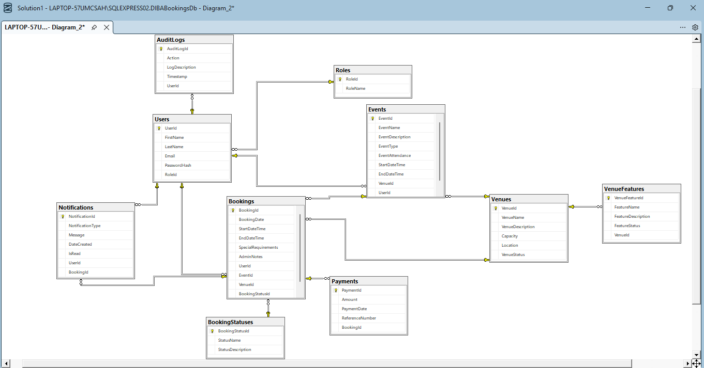
Figure 5: Relational Database Model Diagram

1.9 User Interface Design

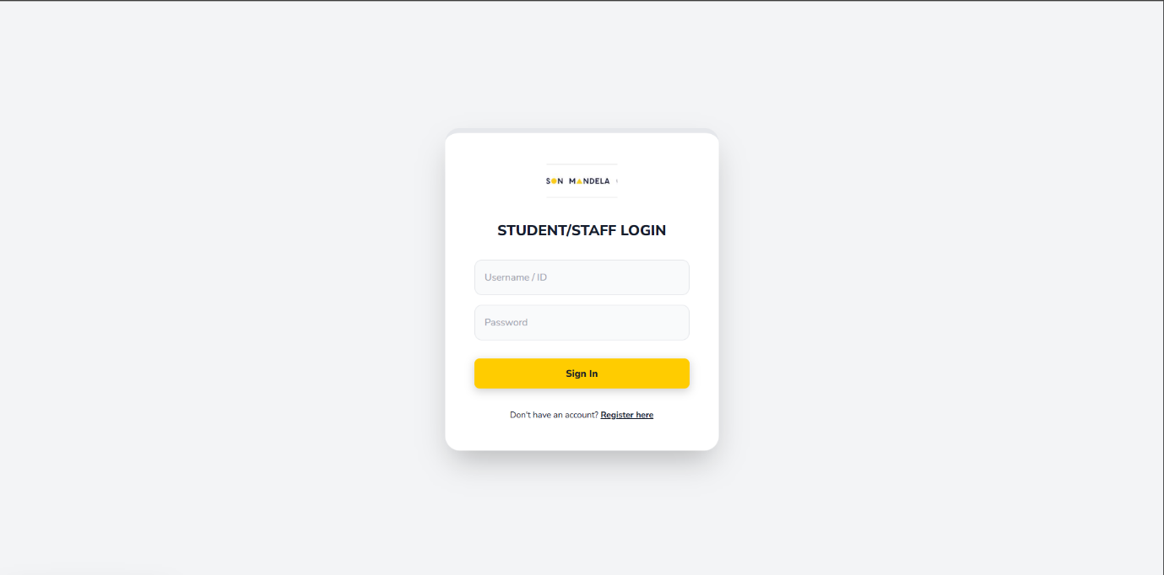
Login screen
Figure 4: Registration screen for all users of the system

Registration screen
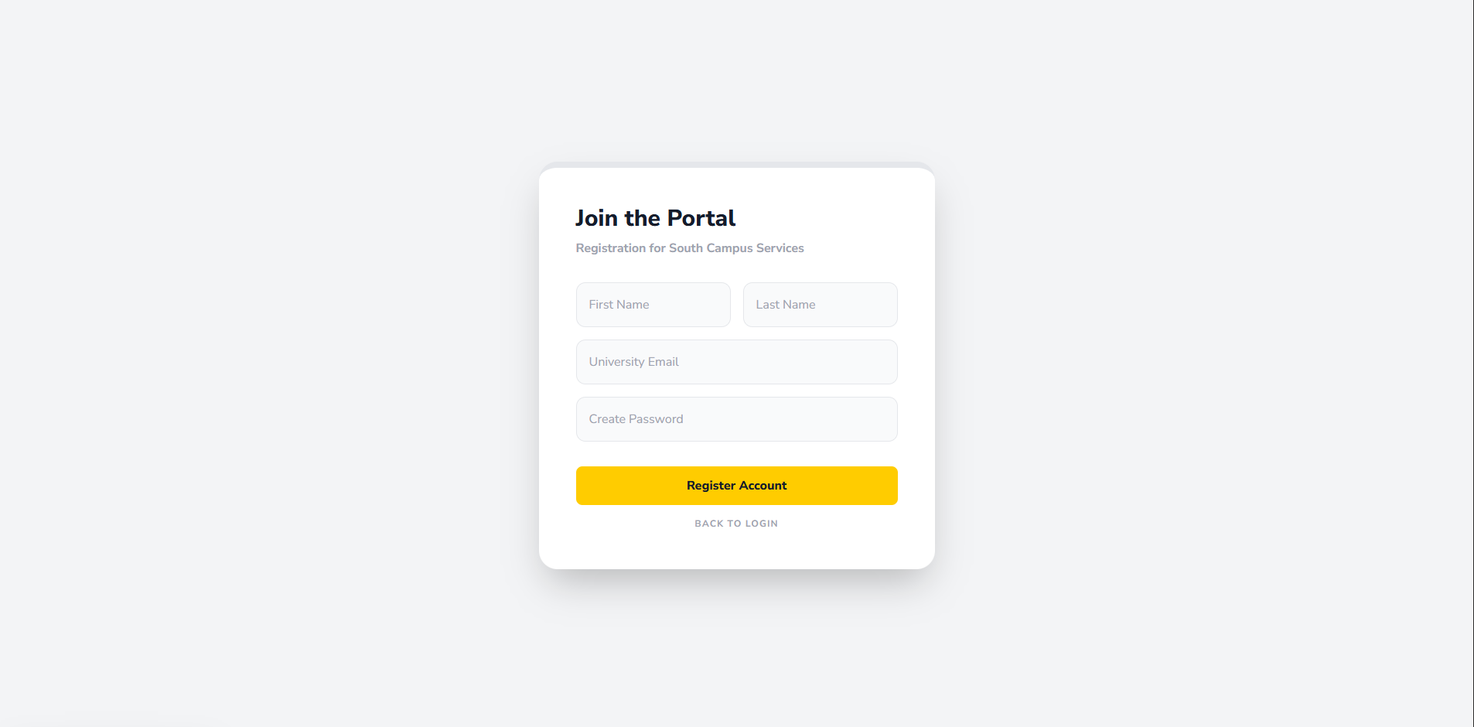
Figure 5: Registration screen for new users

Event organiser

Search and view venue screen
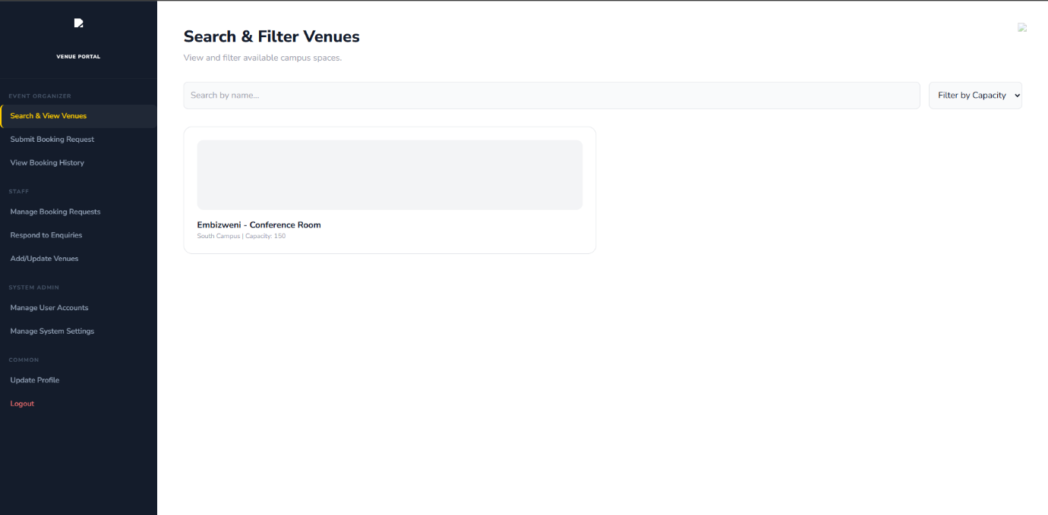
Figure 6: for the event organisers the search and view venue screen.

Submission of booking requests
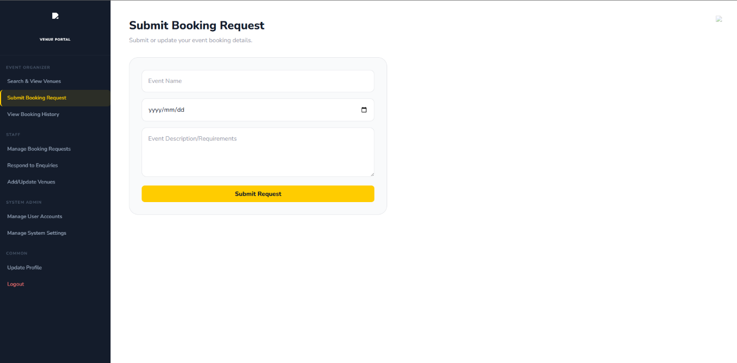
Figure 7: For the event organizer submitting the booking request that will be handled by staff.

Viewing of booking history
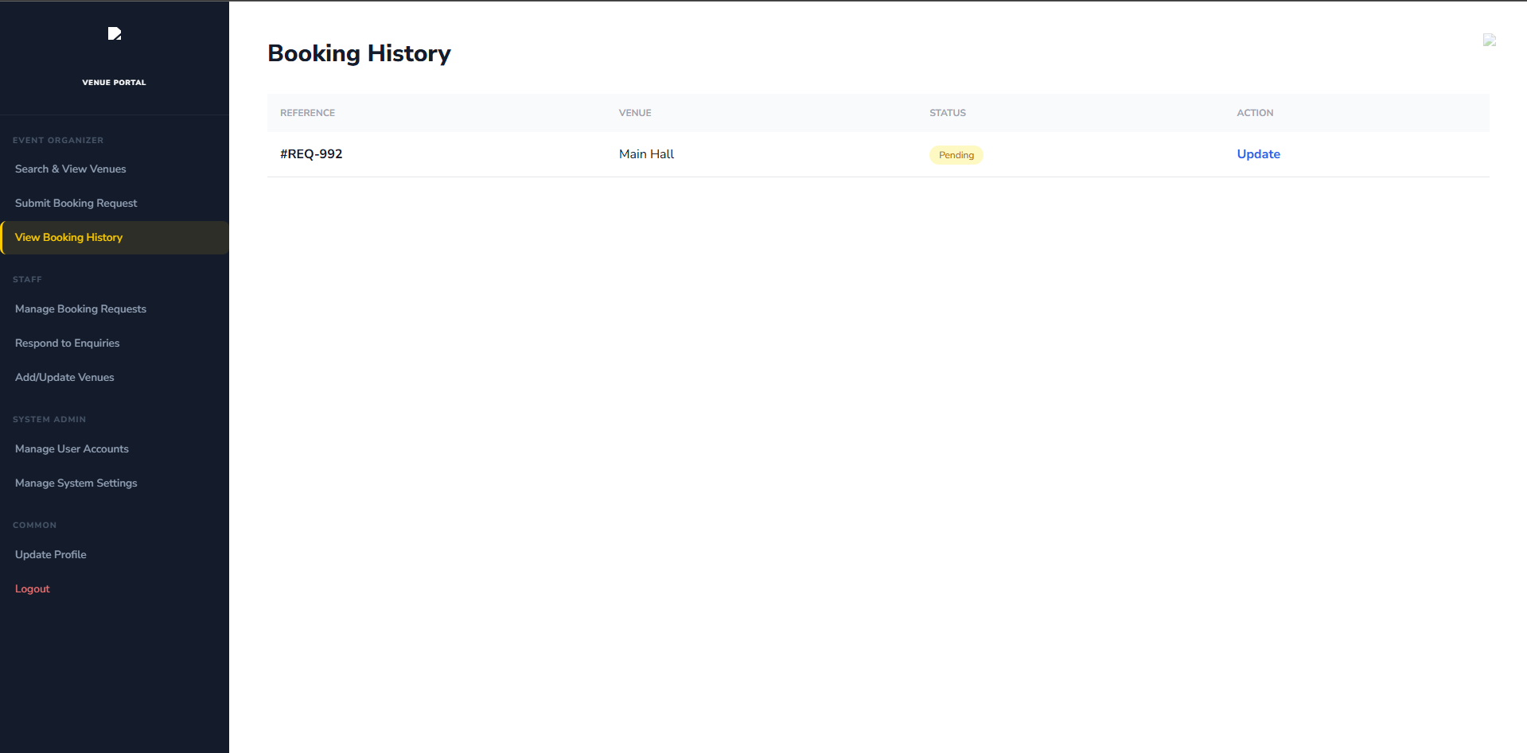
Figure 8: event organizer is also able to view to their booking history.

Staff

Managing booking requests
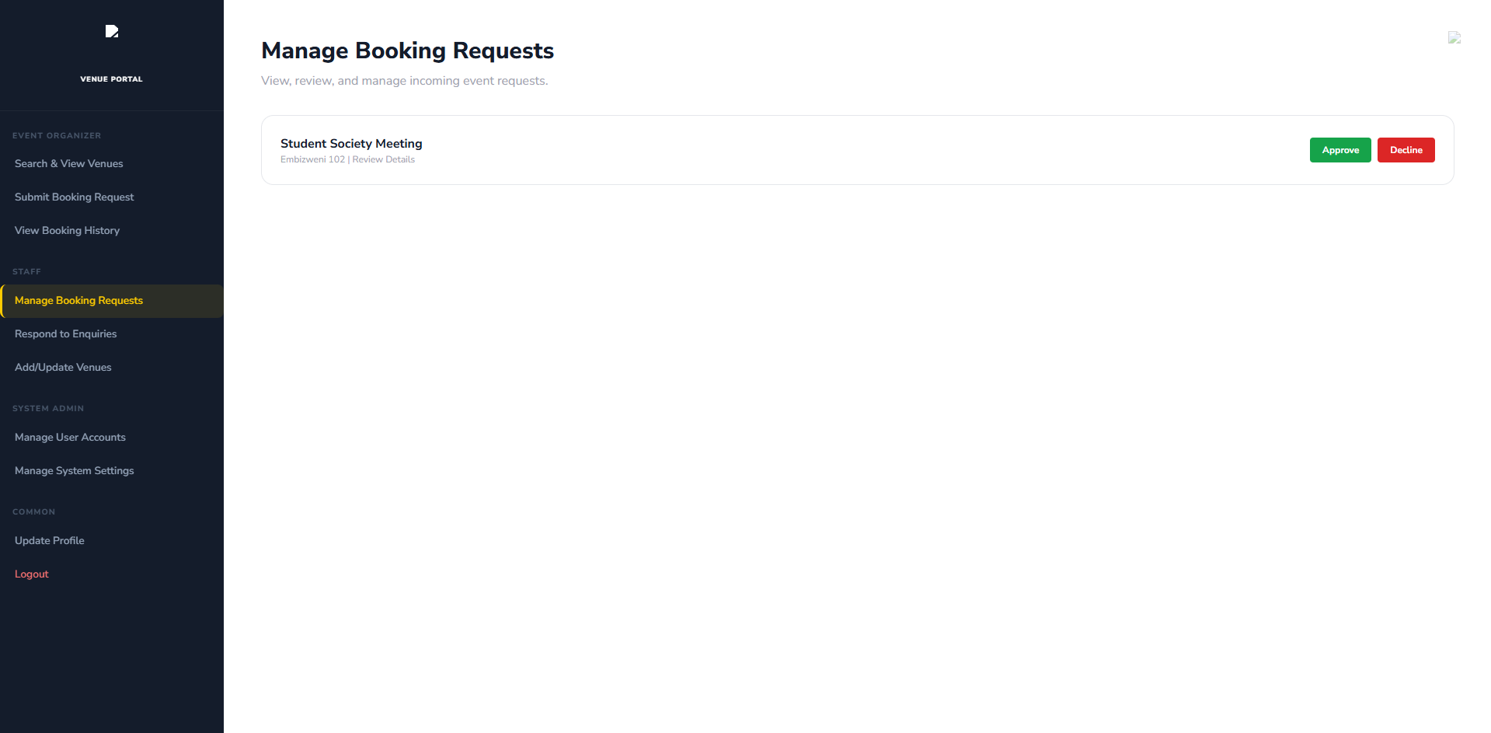
Figure 9: staff is able to manage to booking requests.

Responding to enquiries
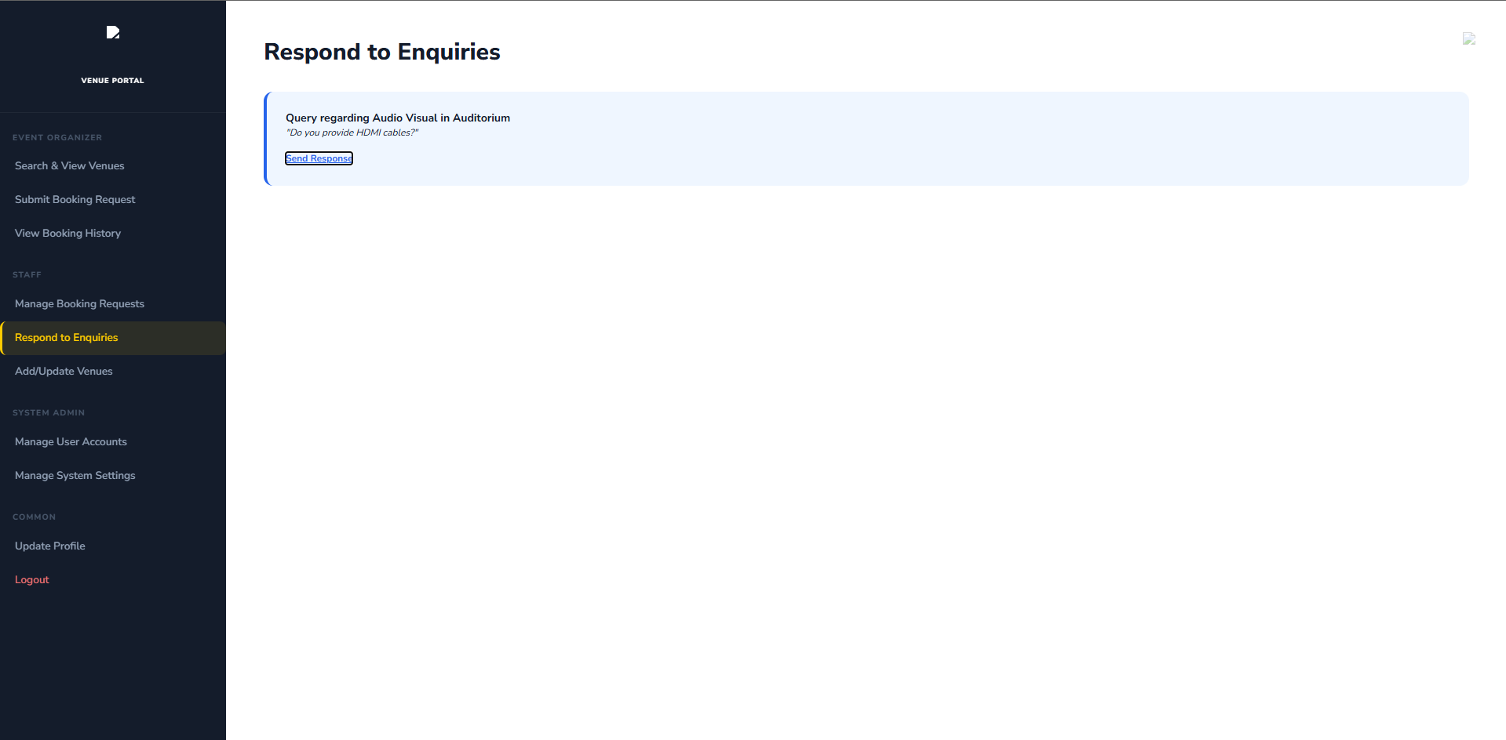
Figure 10: being able to respond to enquiries is an important feature for staff too.

Adding and updating of venues
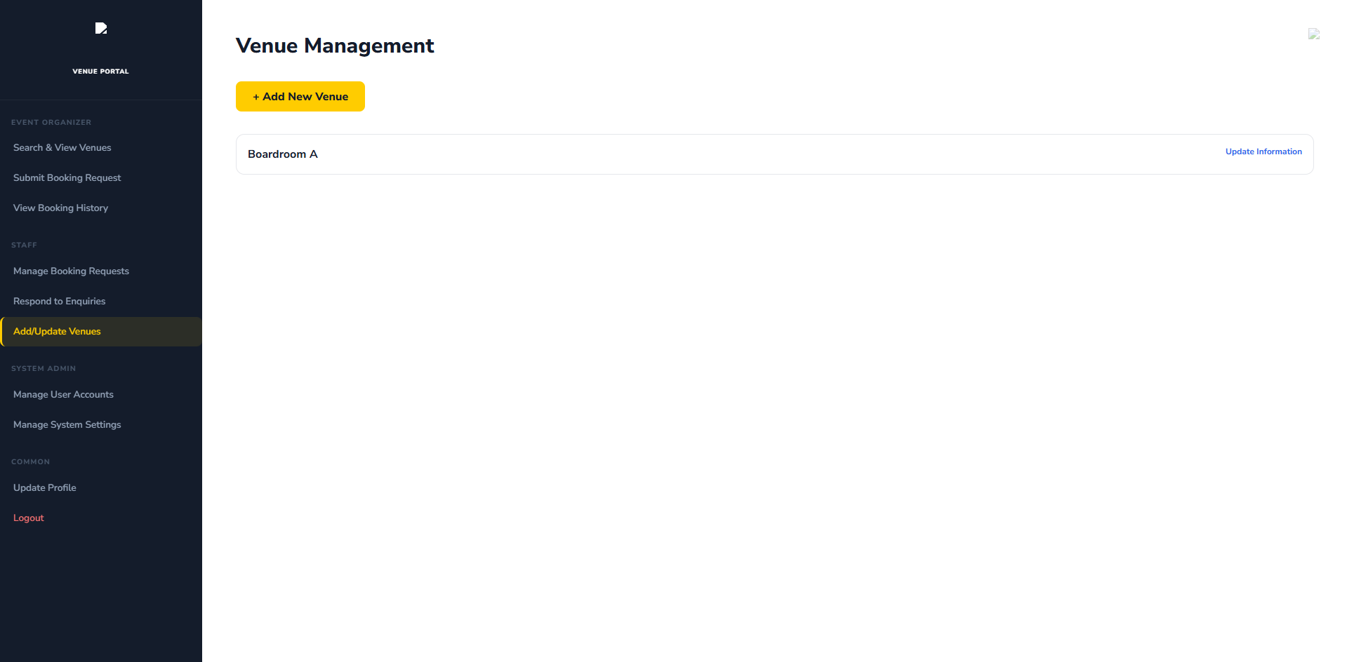
Figure 11: adding and updating of venues by staff

System admin

User account management
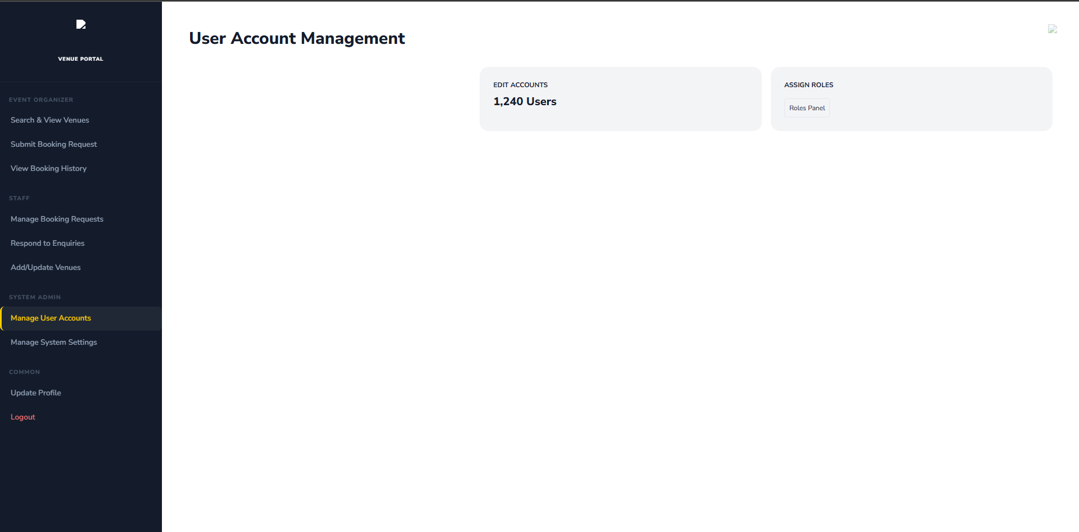
Figure 12: Managing the user accounts by system admin.

Management system settings
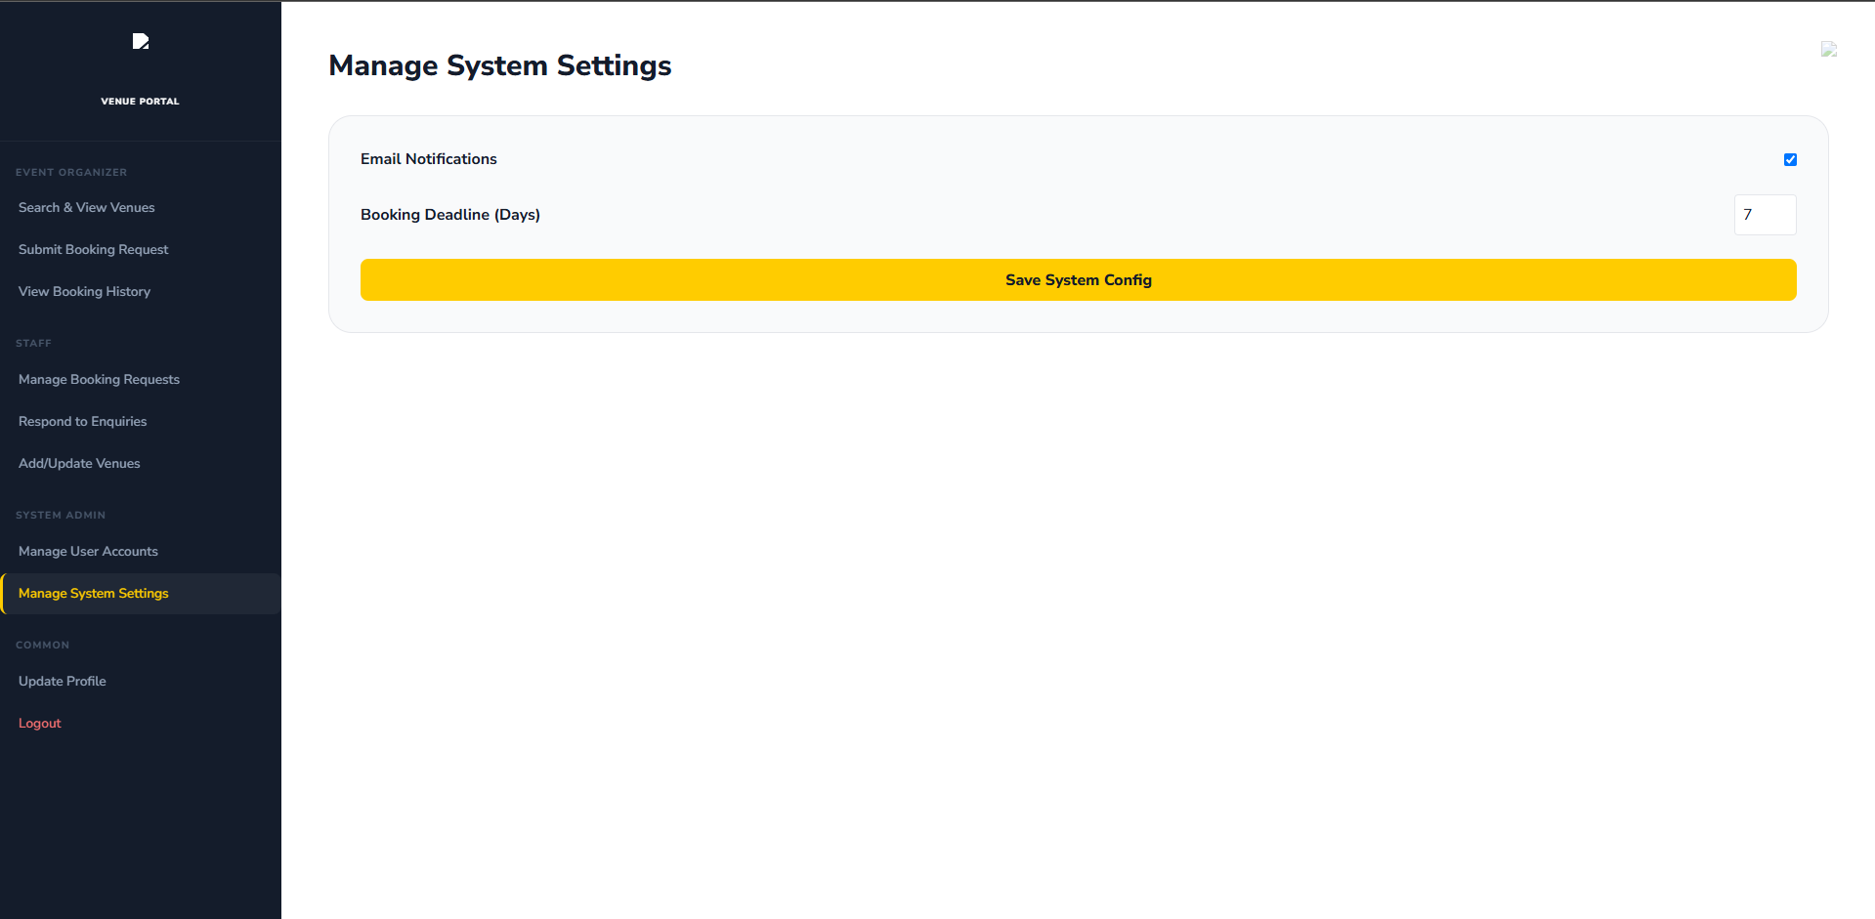
Figure 13: Managing the system setting. To add new venue that might get built in future or delete venues that have been demolished or changed.

Update Profile
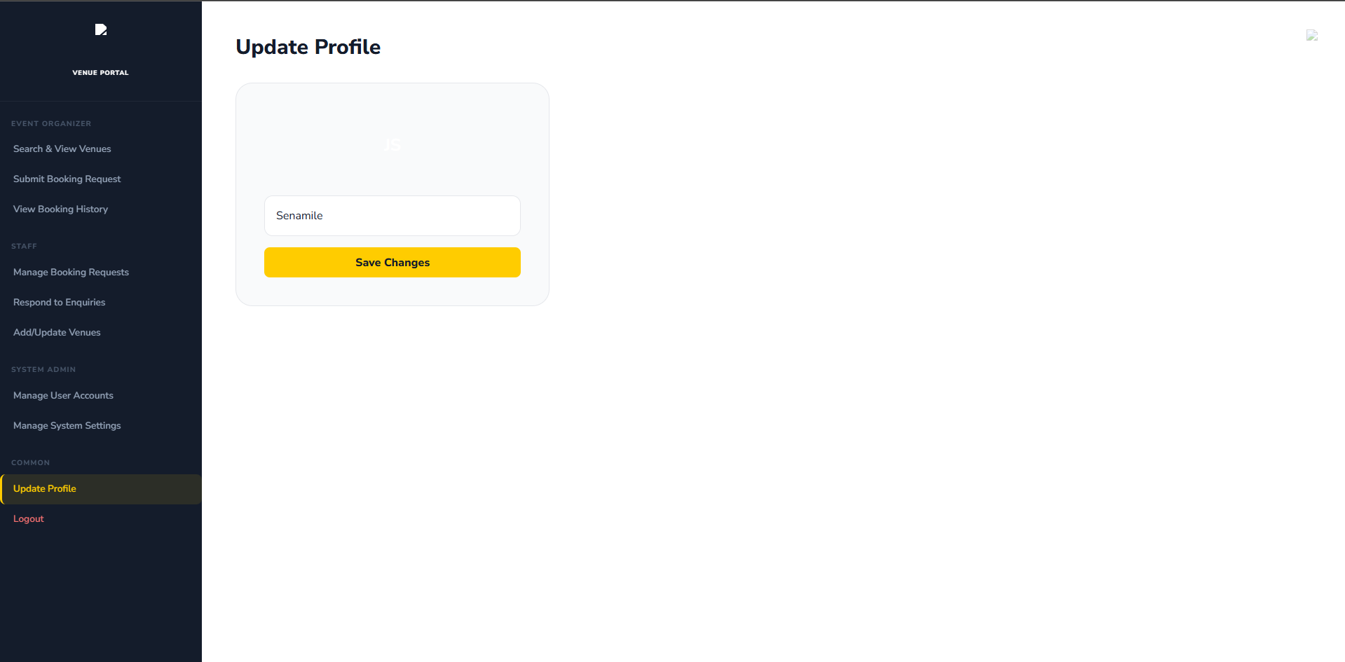
Figure 14: Common feature for all the potential user is updating of the profiles.

Implementation Document

Introduction
The implementation phase involved turning the requirements and technical design of the DIBA Bookings system into a working web application. The system was developed to manage venues, events, bookings, users, notifications, payments and administrative activities at the Nelson Mandela University Conference Centre. The system has three main user roles: Event Organisers, Conference Centre Staff and System Administrators. Each role has different permissions based on its responsibilities.
The application consists of a React frontend, an ASP.NET Core Web API backend and a Microsoft SQL Server database. The backend manages the system rules, authentication, authorisation and communication with the database. This document describes the tools used, complex code developed, external sources used, and problems encountered during implementation and how they were solved.

1.1 Choice of Tools
The tools used to develop the DIBA Bookings system were selected based on the project requirements, the system design and the different stages of development. They supported programming, database development, interface design, testing, version control, communication, documentation and technical research.

1.1.1 Microsoft Visual Studio 2022
Microsoft Visual Studio was used as the main development environment for the backend. It was used to create the ASP.NET Core Web API, write C# code, manage the project and debug errors.
It was selected because it supports C#, ASP.NET Core and Entity Framework Core, which were required for the backend.

1.1.2 ASP.NET Core Web API
ASP.NET Core Web API was used to develop the backend of the system. It connects the React frontend to the database and handles functions such as authentication, authorisation, validation, bookings, venues, events, notifications and payments. The API also allowed the backend to be tested separately from the frontend.

1.1.3 C#
C# was used as the main programming language for the backend. It was used to create controllers, entities, data transfer objects, authentication logic and other backend functionality. C# also allowed the main parts of the system, such as users, venues, events and bookings, to be represented as classes.

1.1.4 Entity Framework Core
Entity Framework Core was used to connect the C# backend to the database. It allowed database tables and relationships to be represented using C# classes. It was used for tasks such as creating, retrieving and updating records, checking bookings and managing relationships between entities.

1.1.5 Microsoft SQL Server Express
Microsoft SQL Server was used as the database management system. It stores information about users, roles, venues, venue features, events, bookings, notifications, payments and audit logs. Primary keys and foreign keys were used to connect related records. SQL Server was selected because it was part of the project requirements and works well with ASP.NET Core and Entity Framework Core.

1.1.6 SQL Server Management Studio
SQL Server Management Studio (SSMS) was used to manage and inspect the database during development. It was used to view tables and records, run SQL queries and check whether information was being correctly saved by the application.

1.1.7 React
React was used to develop the frontend of the system. It was used to create the pages, forms, navigation, dashboards and other parts of the user interface. React communicates with the ASP.NET Core API to send and receive information.

1.1.8 Google AI Studio and Lovable
Google AI Studio and Lovable were used to plan and design the user interface before and during development. It helped the team plan the layout, navigation, colours, forms and general appearance of the system before implementing the designs in React.

1.1.9 Swagger
Swagger was used to document and test the backend API. It allowed the team to view the API endpoints and send requests directly to the backend. This helped test features before connecting them to the React frontend.

1.1.10 Git
Git was used for version control. It allowed changes to the source code to be tracked and previous versions to be reviewed when problems occurred.

1.1.11 GitHub
GitHub was used to store and manage the project's source code repositories. It provided a central location for the code and supported collaboration between team members. GitHub was also useful for keeping a remote copy of the project.

1.1.12 Microsoft Edge
Microsoft Edge was used to run and test the React frontend. It was used to inspect the frontend, identify console errors and check network requests between the frontend and backend.

1.1.13 Microsoft Word
Microsoft Word was used to prepare the project documentation and reports. It was used for writing, formatting and organising the required project documents.

1.1.14 WhatsApp
WhatsApp was used for communication and project coordination. It was used to discuss tasks, share updates, arrange meetings and communicate about development problems.

1.1.15 ChatGPT
ChatGPT was used as a supporting development and research tool. It helped the team understand technical concepts, investigate errors, discuss possible solutions and improve explanations. Suggestions from the tool were reviewed and adapted by the team before being used.

1.1.16 DeepSeek
DeepSeek was used as an additional AI-assisted development tool. It was used to help understand programming problems, compare possible solutions and assist with debugging. The suggestions provided were reviewed and tested before being used in the project.

1.1.19 Microsoft Learn and Online Technical Documentation
Microsoft Learn and other official technical documentation were used as reference material during development. They were used to understand technologies such as ASP.NET Core, Entity Framework Core, C#, authentication and other Microsoft technologies.

1.1.20 Previous Academic Material and GitHub Projects
Previous academic material, lecture content and relevant GitHub projects were used as technical reference material. These resources helped the team understand implementation approaches and programming concepts. Any externally sourced code or material used in the system is discussed separately in Section 1.3.

1.1.21 Microsoft Excel
Microsoft Excel and other project coordination methods were used to organise the development work. The team used these methods to track tasks, coordinate responsibilities, monitor progress and work towards project deadlines. These methods helped the team divide the project into smaller tasks and keep track of work that still needed to be completed.

1.2 Extracts of Complex Code
The DIBA Bookings system contains several sections of code that required more development work than simple database operations. The selected extracts below focus on code that implements important business rules and system processes. The extracts show how the requirements of the DIBA Bookings system were implemented in the final application.

1.2.1 Booking Conflict Validation
Booking conflict validation was an important part of the booking process. The system must prevent two bookings from using the same venue at overlapping times. The following code checks whether the selected venue already has a pending or approved booking during the requested time:
var hasConflict = await _dbContext.Bookings
.AnyAsync(booking =>
booking.VenueId ==
createBookingDto.VenueId &&

booking.StartDateTime <
createBookingDto.EndDateTime &&

booking.EndDateTime >
createBookingDto.StartDateTime &&

booking.BookingStatus != null &&

(
booking.BookingStatus.StatusName == "Pending" ||
booking.BookingStatus.StatusName == "Approved"
));

if (hasConflict)
{
return Conflict(
"The selected venue is already booked or awaiting approval for the requested time.");
}
The code checks the venue, start time, end time and booking status. If an existing booking overlaps with the requested time, the system does not allow the new booking to continue. A 409 Conflict response is returned to the frontend when a conflict is found. After the checks have passed, the booking is created with a Pending status:
var booking = new Booking
{
BookingId = Guid.NewGuid(),
BookingDate = DateTime.UtcNow,
StartDateTime =
createBookingDto.StartDateTime,
EndDateTime =
createBookingDto.EndDateTime,
SpecialRequirements =
createBookingDto.SpecialRequirements,
AdminNotes = null,
UserId = userId,
EventId = createBookingDto.EventId,
VenueId = createBookingDto.VenueId,
BookingStatusId =
pendingStatus.BookingStatusId
};

_dbContext.Bookings.Add(booking);

await _dbContext.SaveChangesAsync();
This makes the booking process more than a simple database insert because the system checks whether the booking is allowed before saving it.

1.2.2 Booking Approval and Rejection
Booking approval and rejection form part of the administrative workflow. A booking must first be in a Pending state before it can be approved. The following code checks the current booking status:
if (!currentStatus.StatusName.Equals(
"Pending",
StringComparison.OrdinalIgnoreCase))
{
return BadRequest(
"Only pending bookings can be updated.");
}

booking.BookingStatusId =
approvedStatus.BookingStatusId;
When a booking is approved, the system also records the action and creates a notification for the Event Organiser.
var auditLog = new AuditLog
{
AuditLogId = Guid.NewGuid(),
Action = "Booking Approved",
LogDescription =
$"Booking {booking.BookingId} was approved.",
Timestamp = DateTime.UtcNow,
UserId = userId
};

_dbContext.AuditLogs.Add(auditLog);

var notification = new Notification
{
NotificationId = Guid.NewGuid(),
NotificationType = "Booking Approved",
Message =
"Your venue booking has been approved.",
DateCreated = DateTime.UtcNow,
IsRead = false,
UserId = booking.UserId,
BookingId = booking.BookingId
};

_dbContext.Notifications.Add(notification);

await _dbContext.SaveChangesAsync();
This means that one administrative action updates the booking, records the action and informs the user.
The rejection process also checks that a reason has been provided:
if (string.IsNullOrWhiteSpace(
rejectBookingDto.Reason))
{
return BadRequest(
"A rejection reason is required.");
}

booking.AdminNotes =
rejectBookingDto.Reason;

booking.BookingStatusId =
rejectedStatus.BookingStatusId;
The rejection reason is stored with the booking and can be included in the notification sent to the Event Organiser.

1.2.3 Notification Retrieval and User-Specific Access
The notification system was implemented so that users only receive notifications belonging to their own account.
The backend first obtains the ID of the logged-in user:
if (!UserHelper.TryGetUserId(
User,
out Guid userId))
{
return Unauthorized(
"User ID could not be determined.");
}
The system then uses this ID when retrieving notifications:
if (!UserHelper.TryGetUserId(User, out Guid userId))
{
return Unauthorized("User ID could not be determined.");
}

var notifications = await _dbContext.Notifications
.Where(notification => notification.UserId == userId)

.OrderByDescending(notification => notification.DateCreated)

.Select(notification => new NotificationResponseDto
{
NotificationId = notification.NotificationId,
NotificationType = notification.NotificationType,
Message = notification.Message,
DateCreated = notification.DateCreated,
IsRead = notification.IsRead,
UserId = notification.UserId,
BookingId = notification.BookingId
})
.ToListAsync();
The Where() condition makes sure that only notifications belonging to the logged-in user are returned. The OrderByDescending() method places the newest notifications first.
The system can also mark unread notifications as read:
var notifications = await _dbContext.Notifications
.Where(notification =>
notification.UserId == userId &&
!notification.IsRead)
.ToListAsync();

foreach (var notification in notifications)
{
notification.IsRead = true;
}

await _dbContext.SaveChangesAsync();
This allows the system to keep track of which notifications have already been viewed.

1.2.4 Audit Logging
Audit logging was implemented to keep a record of important actions performed in the system. An audit record contains information such as the action, description, time and user who performed the action.
The following code retrieves audit records and the user connected to each record:
var auditLogs = await _dbContext.AuditLogs

.Include(auditLog =>
auditLog.User)
.OrderByDescending(auditLog =>
auditLog.Timestamp)
.Select(auditLog =>
new AuditLogResponseDto
{
AuditLogId =
auditLog.AuditLogId,

Action =
auditLog.Action,

LogDescription =
auditLog.LogDescription,

Timestamp =
auditLog.Timestamp,

UserId =
auditLog.UserId,

UserName =
auditLog.User == null
? string.Empty
: auditLog.User.FirstName +
" " +
auditLog.User.LastName
})
.ToListAsync();
The code retrieves the audit records, includes the related user, places the newest records first and prepares the information needed by the frontend.
Audit records are also created when important actions such as booking approval, rejection and cancellation take place. This allows administrators to see what action was performed and which user performed it.

1.3 Source Code References
External sources were used during development to understand common programming solutions and implementation approaches. These sources included GitHub projects, Microsoft Learn and Stack Overflow. The sources were used as technical references and, where appropriate, ideas or code were adapted to meet the requirements of the DIBA Bookings system. The final implementation was changed to fit the system's database structure, user roles and business rules.

1.3.1 Role-Based Authorisation and JWT Authentication

Description
External examples were used to understand how JWT authentication and role-based authorisation can be implemented in an ASP.NET Core Web API. The examples helped with understanding how users can be authenticated and how access can be restricted according to their roles. The ASP.NET Core documentation also explains how the [Authorize] attribute can be used to restrict access to specific roles. (olaideogunbunmi, 2026); (Microsoft, 2026)

Usage in DIBA Bookings
This approach was adapted for the DIBA Bookings backend. The system uses different roles, including Administrator, Conference Centre Staff and Event Organiser. Role restrictions are used on protected controllers and actions, such as administrative functions and booking management.

1.3.2 Booking Conflict Validation

Description
A meeting-room reservation project was reviewed to understand how a booking system can prevent two users from reserving the same room for overlapping times. The project uses validation to prevent overlapping reservations (ouardini14, 2022).

Usage in DIBA Bookings
The approach was adapted for the DIBA Bookings system. Before a booking is created, the backend checks whether another booking exists for the selected venue and time period. Pending and Approved bookings are considered when checking for conflicts. If a conflict is found, the system stops the booking from being created.

1.3.3 Conference Booking and Approval Processes

Description
A conference booking API was reviewed to understand how a backend system can manage conference rooms, reservations and user access. The project uses ASP.NET Core and includes booking management and role-based access (JedAngelo, 2024). Also was reviewed to understand how bookings, events, notifications and administrative actions can work together in one system.

Usage in DIBA Bookings
These ideas were adapted for the DIBA booking process. An Event Organiser creates a booking, after which Conference Centre Staff can approve or reject it. The system also requires a rejection reason when a booking is rejected. When a booking is approved or rejected, the system creates a notification for the Event Organiser and records the action in the audit log.

1.3.4 User Notifications

Description
An ASP.NET Core notification service was reviewed to understand how notifications can be stored and provided to individual users. The project includes single-user notifications and read/unread tracking. (Hisham, 2026)
A personal finance dashboard project was also reviewed because it includes a notification service with user-based notification retrieval and a mark-as-read function (Iriarte, 2026).

Usage in DIBA Bookings
The notification approach was adapted for DIBA Bookings. Notifications are linked to individual users and can also be linked to a booking. Users can retrieve their own notifications, view whether a notification has been read and mark unread notifications as read.

1.3.5 Audit Logging

Description
The Accessly project was reviewed to understand how important system actions can be recorded in an audit log. The project records actions together with information about the actor and affected entity (Lakhili, 2026).
The Headless Framework project was also reviewed because it includes audit logging as one of its backend features (Shaheen, 2026).

Usage in DIBA Bookings
The audit logging approach was adapted for DIBA Bookings. The system records important actions such as booking approval, booking rejection and booking cancellation. The audit record stores information such as the action, description, date and user who performed the action. This allows administrators to review important activities in the system.

1.3.6 Summary of Adapted External Sources
The external sources were not used as complete solutions for DIBA Bookings. They were used to understand specific technical problems and possible ways of solving them. The approaches were then changed to fit the DIBA system.
External concept | DIBA Bookings adaptation
JWT and role-based authorisation | Adapted for Administrator, Conference Centre Staff and Event Organiser roles.
Booking conflict detection | Adapted to check venue, date/time overlap and booking status.
Conference booking management | Adapted to support DIBA's booking, approval and rejection process.
User notifications | Adapted to provide user-specific booking notifications and read/unread status.
Audit logging | Adapted to record important booking and administrative actions.
The external sources therefore supported the development process, but the final implementation was structured around the specific requirements and database design of the DIBA Bookings system.

1.4 Problems Encountered
Several problems were encountered during the development of the DIBA Bookings system. The problems included technical difficulties, limited development time, access to computers, team coordination and the amount of work required to develop the system from the beginning.

1.4.1 Developing the Project Idea and Requirements
One of the first challenges was that the team was not given an existing application to improve or a complete system specification to follow. The DIBA Bookings idea was developed by the team and then proposed to the lecturer.
This meant that the team had to decide what problem the system would solve, what features it should have, who would use it and how the booking process should work. The team had to identify the different users, including Event Organisers, Conference Centre Staff and System Administrators. The team also had to decide what each user should be allowed to do.
This required the team to spend time discussing the idea, researching possible solutions and changing some parts of the system before development could begin. The problem was managed by breaking the project into smaller requirements and documenting the system before implementing the main features.

1.4.2 Designing the System Before Development
Another challenge was creating the technical design of the system. The team had to create the Software Requirements Specification (SRS) and design the structure of the application before implementing it. This included deciding what information the system needed, how the different parts of the system would connect and how users would interact with the system.
Creating the class diagram in Visual Studio was also part of this process. The team had to identify the main classes, their properties and the relationships between them. For example, the team had to determine how Users, Roles, Events, Venues and Bookings should be related.
This was difficult because changes made to the design could also affect the database, backend and frontend. The problem was managed by reviewing the requirements and gradually improving the system design before implementing the related features.

1.4.3 Creating the Database Structure
After designing the system, the team had to create the database structure required by the application. The team understood the information that needed to be stored, but it was initially difficult to understand how the C# entity classes, Entity Framework Core, the DbContext and SQL Server worked together.
The team had to ask questions such as:
- which tables were required?
- which fields were needed?
- which fields should be primary keys?
- which fields should be foreign keys?
- how tables should be related? and
- how changes to one part of the system could affect related records?
The problem was addressed by studying Entity Framework Core documentation, reviewing the class design and testing the database relationships during development. The team gradually corrected the entity relationships and database configuration until the backend could successfully communicate with the database.

1.4.4 Complexity of the Bookings Controller
The booking functionality became one of the most complicated parts of the system. At the beginning, creating a booking appeared to be a simple process. However, as the requirements were implemented, the booking process required many checks and actions.
The controller eventually had to handle:
- creating bookings;
- checking dates;
- checking that venues exist;
- checking venue availability;
- checking that events belong to the correct user;
- detecting conflicting bookings;
- updating bookings;
- approving bookings;
- rejecting bookings;
- cancelling bookings;
- changing booking statuses;
- creating notifications; and
- creating audit records.
This caused the BookingsController to become much larger and more complex than initially expected.
The team managed this by separating the different operations into different API endpoints and using DTOs and Entity Framework Core queries to keep each operation focused.

1.4.5 Authentication and Authorisation
Implementing authentication and authorisation was another challenge. The system needed to identify a user after login and then determine what that user was allowed to access.
Several parts had to work together. The user had to log in, the backend had to check the login details, a JWT had to be created, and the frontend had to send the token when accessing protected endpoints. The backend then had to read the token and identify the user's role before allowing or denying access. Understanding how these parts worked together was initially difficult.
The problem was addressed by testing the authentication endpoints using Swagger before connecting them to the React frontend. Different user roles were also tested to check that users could only access functions allowed for their role.

1.4.6 Booking Availability and Conflicting Bookings
Another technical challenge was preventing two users from booking the same venue at overlapping times. The system could not simply check whether a venue already had a booking. It had to compare the requested start and end times with existing bookings. For example, if a venue was booked from 10:00 to 12:00, another booking from 11:00 to 13:00 should not be allowed.
The team therefore had to understand how date and time ranges overlap and then apply this logic to the DIBA Bookings requirements. The final implementation checks the venue, the requested time period and the status of existing bookings before creating a new booking.

1.4.7 Managing Booking Statuses
The booking process also became more complicated because bookings could have different statuses.
The system uses statuses such as:
- Pending;
- Approved;
- Rejected;
- Cancelled; and
- Completed.
Not every action should be available for every status. For example, a pending booking can be approved or rejected, while an already rejected booking should not be approved. The team therefore had to add checks before allowing status changes. This required the team to think about the booking process as a sequence of possible states rather than treating every booking in the same way.

1.4.8 Frontend and Backend Communication
Connecting the React frontend to the ASP.NET Core backend was another challenge. The frontend had to send requests to the correct API endpoints and provide the information expected by the backend. The backend also had to return information in a format that the frontend could use.
A problem on either side could cause a feature to fail even when the other side was working correctly. The team addressed this by testing the backend endpoints separately using Swagger before connecting them to the React frontend. This made it easier to identify whether a problem was coming from the frontend or backend.

1.4.9 Testing Role-Specific Functionality
Testing was challenging because the system has different user roles with different permissions. An Event Organiser, Conference Centre Staff member and System Administrator should not have access to exactly the same functions.
The team therefore had to create and test different user accounts and check both allowed and restricted actions. This helped identify authorisation problems and confirmed that role-based access was being applied correctly.

1.4.10 Coordinating Work Between Team Member
The team's different class schedules also affected development. There were times when one team member was in class while the other was available to work on the project. This made it difficult to always work on the same part of the system at the same time.
The team managed this by communicating about completed work, sharing changes through GitHub and continuing with separate tasks when both members were not available at the same time. This allowed development to continue even when the team members were not physically working together.

1.4.11 Limited Development Time and Laboratory Access
Limited access to university computers was another major challenge. The team was not given enough time to use the laboratory computers for all the work required by the project. The laboratories also had limited operating hours, which reduced the amount of time available for development.
This was especially difficult because software development often requires time to install tools, open the development environment, build the application, test the system and investigate errors.
There were situations where the team was still working on a problem when the available laboratory time was ending. The team therefore had to make careful use of the available laboratory time and continue working outside the laboratories when possible. This limitation affected the speed of development and required the team to manage its time carefully.

1.4.12 Slow Development Computers
The performance of our computers also affected development. Opening Visual Studio, building the backend, running SQL Server and testing the application could take a significant amount of time on slower computers.
This increased the time needed to test changes and investigate problems. The team managed this by planning tasks carefully and using available development time as efficiently as possible.

1.4.13 Managing the Project Timeline
Because the team had to develop the project from the idea stage, there were many deliverables that had to be completed before the final implementation. The team therefore created a project outline using Microsoft Excel to schedule the deliverables and planned when different parts of the project should be completed.
However, technical problems sometimes took longer to solve than expected. This caused some planned tasks to take longer and affected later tasks. The team responded by changing priorities when necessary and focusing on important tasks first.
1.4.15 Map and Location Functionality
Location functionality also required additional consideration. The system was designed to provide users with information about venue locations. The team therefore had to decide how location information should be presented while keeping the feature within the scope of the project.
The team focused on providing useful venue location information without making the location feature unnecessarily complicated.

1.5 Implementation Summary
The implementation phase changed the DIBA Bookings idea developed by the team into a working web application. The team was responsible for developing the idea, proposing it to the lecturer, identifying the system requirements, designing the system and implementing the final application. The team was not given an existing application or complete system to build from.
The final system consists of a React frontend, an ASP.NET Core Web API backend and a Microsoft SQL Server database.
The main implemented features include:
- user registration and authentication;
- role-based access;
- venue management;
- event management;
- booking creation;
- booking availability checking;
- booking approval and rejection;
- booking cancellation;
- notifications;
- payment records;
- audit logging; and
- administrative functionality.
The implementation process involved both technical and practical challenges. The team had to learn how the different technologies worked together, create the system design and database structure, implement authentication and authorisation, develop booking rules and connect the frontend to the backend. The team also had to work with limited laboratory access, slow computers, different class schedules and a limited project timeline.
Despite these challenges, the team continued to develop and test the system until the main planned functionality was implemented. The final application reflects the requirements and design developed by the team during the project.

References
Hisham, O. (2026). Omar Hisham. Retrieved from gihub: https://github.com/Oh011/NotificationService.git
Iriarte, J. M. (2026). Microservices Infrastructure Personal Finance Dashboard. Retrieved from github: https://github.com/tigerbluejay/Microservices-Infrastructure-Personal-Finance-Dashboard.git
JedAngelo. (2024). ConferenceBookingAPI. Retrieved from gihub: https://github.com/JedAngelo/ConferenceBookingApi.git
Lakhili, M. (2026). Accessly. Retrieved from github: https://github.com/LMouhssine/Accessly.git
Microsoft. (2026). Microsoft Ignite. Retrieved from Microsoft Learn: https://learn.microsoft.com/en-us/aspnet/core/security/authorization/roles?view=aspnetcore-10.0&utm_source=chatgpt.com
olaideogunbunmi. (2026). Retrieved from Gihub: https://github.com/olaideogunbunmi/aspnetcore-auth-rbac.git
ouardini14. (2022). Meeting-room-reservation-api. Retrieved from github: https://github.com/ouardini14/Meeting_Planner.git
Shaheen. (2026). Headless Framework. Retrieved from github: https://github.com/xshaheen/headless-framework.git

excel. (n.d.). Retrieved from Vertex42.com: https://www.vertex42.com/ExcelTemplates/simple-gantt-chart.html

